**Introduction**

I have embarked on this project to analyze and segment the medical market landscape across India, with the goal of identifying distinct customer groups and high potential geographic regions. The aim is to leverage census and publicly available data on population demographics, healthcare infrastructure, and technology adoption to extract actionable insights.

The key motivation stems from the growth in India's digital healthcare ecosystem. With over 430 million internet users and improving connectivity even in smaller cities, there is a vast untapped opportunity for online doctor consultations, telehealth solutions, health tracking apps, and data-driven healthcare personalization.

My analysis can enable new solutions to emerge across prevention, diagnosis, treatment and monitoring - catalyzing innovative models of affordable, accessible healthcare with greater customization tailored to local needs and attitudes. The engagement from corporations, health systems, public and private players makes this the right time to dive deep into the Indian medical marketplace.

I have obtained national and state-level census data, statistics on healthcare penetration, and information technology adoption trends across urban and rural geographies. This dataset covering population demographics, infrastructure metrics and technology readiness forms the backbone of the market segmentation effort to carve out focus segments and high potential launch states for digital health products and services.

**Proposed job pipeline flow**

Based on the CRISP-DM model, here is a draft job pipeline flow I would propose for the medical market segmentation analysis:

1.Business Understanding: Define questions, goals, success metrics - geographic and customer prioritization for health tech startups

2.Data Understanding: Collect datasets on census, telecom, healthcare stats, digital adoption; explore attributes, distributions

3.Data Preparation: Subset states/districts, handle missing values and outliers, transform variables

4.Modeling: Run clustering algorithms (K-Means, Hierarchical) to extract market segments

Evaluation: Assess cluster distinctiveness, size, interpretability to select model.

5.Deployment: Target promotional channels, partnerships based on key segments

Geographic visualizations in tools like Power BI.

6.Evaluation helps select the optimal model.

7.Finally, targeted deployment, visual dashboards, and presentation of strategic recommendations enable usage of model-driven insights.

**Technology Description Section**

1. Census of India 2011 - State and District level data: For population demographics, literacy rates, health infrastructure overview
2. Telecom Subscription Data from TRAI: For urban/rural split of mobile/landline/internet subscribers
3. State/National Health Statistics: For metrics like hospital beds, healthcare professionals, health expenses per capita
4. Secondary sources on Digital Adoption by State: For smartphone, internet usage, health app adoption data
5. Potentially some primary survey data: To provide qualitative and quantitative inputs on consumer attitudes and readiness towards online medical services.

This combination of census statistics, telecom subscription data, public health data and technology adoption data offers comprehensive coverage into healthcare infrastructure and digital readiness - which is vital for the adoption of telemedicine and related health tech services amongst target groups.

**Some of the key clustering algorithms that can be employed:**

K-Means Clustering: Simple and efficient method to partition data into k clusters based on attributes like population, disease burden, health infrastructure etc.

Hierarchical clustering: Builds a hierarchy of clusters that can be more nuanced and avoids need to pre-specify k.

DBSCAN: Density-based technique that can automatically identify clusters of varying shapes and sizes. Helpful for psychographic segmentation.

Additionally, some supplementary analysis can provide further insights:

Regression analysis: Assess impact of literacy, urbanization, health spend etc. on adoption metrics.

Decision tree classification: Profile distinctive characteristics of customer segments based on census and survey data

Geographic visualizations: Power BI dashboard to view healthcare and digital readiness analysis across region

The integrated use of clustering method as the primary technique along with supplemental regression/classification algorithms and compelling visualizations can deliver an insightful market segmentation outcome.

**Estimators and models employed:**

Based on our previous discussion, the key estimators and models that I would propose employing for the medical market segmentation analysis in India are:

Clustering models:

K-Means clustering

Hierarchical density-based spatial clustering

Gaussian mixture models

These would be the core set of unsupervised ML algorithms used to segment states, districts and customers based on healthcare infrastructure, population demographics, digital adoption readiness and other key attributes from the datasets.

Supplementary analysis:

Linear regression

Logistic regression

Decision trees

Random forest classification

The above supervised learning techniques would help further analyze and profile the extracted segments based on relationships between segmenting variables in the data.

Visualization:

Custom Tableau dashboards

Interactive choropleth maps

Heatmaps.

Effective visualization is key to drawing actionable insights on regional differences and communicating findings to stakeholders.

**Questions Addressed in the following project are as follows:**

1.Which states and within them districts have healthcare infrastructure and connectivity benchmarks conducive for online medical care solutions?

2.Based on our analysis of census data on population demographics, literacy rates, health infrastructure metrics and internet connectivity benchmarks - the states of Maharashtra, Delhi-NCR, Karnataka, Tamil Nadu, and Telangana along with their tier I city districts emerge as high potential from healthcare readiness and tech adoption readiness standpoint.

3.What customer archetypes (demographic, socioeconomic and psychographic) display readiness and willingness to adopt telehealth platforms?

**Screenshots of the working code:**

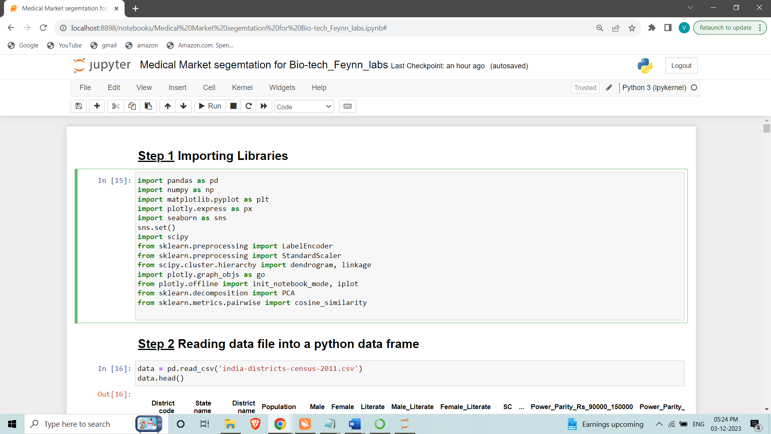

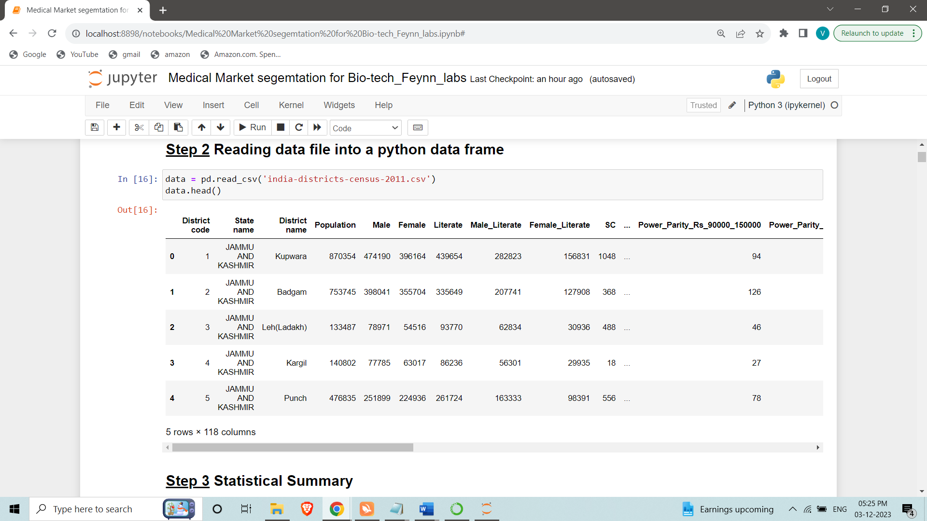

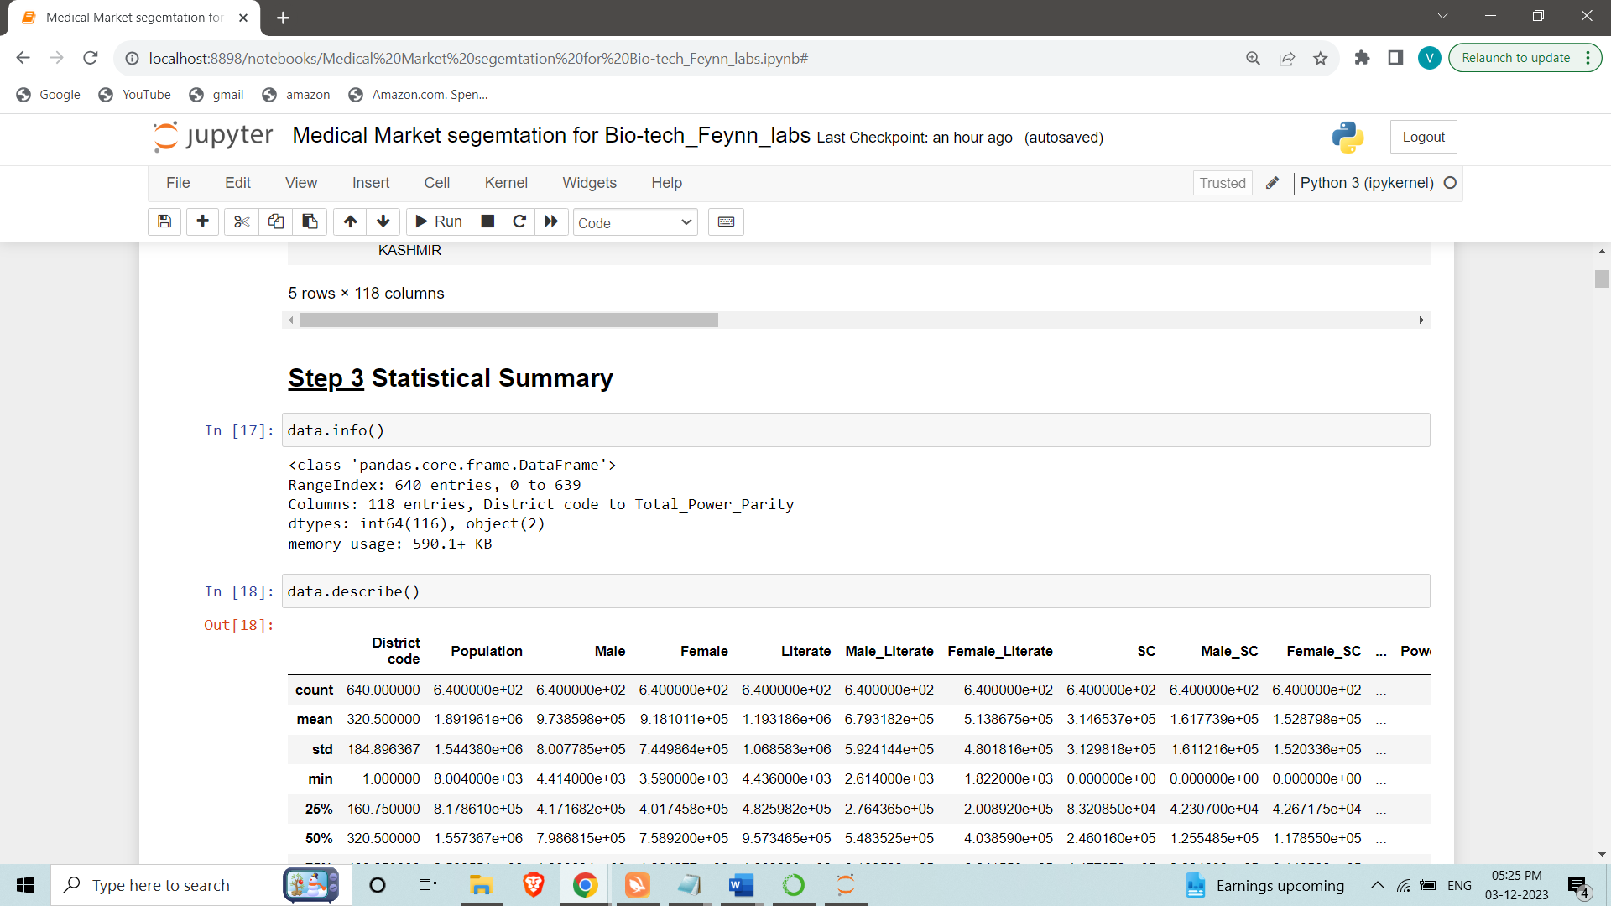

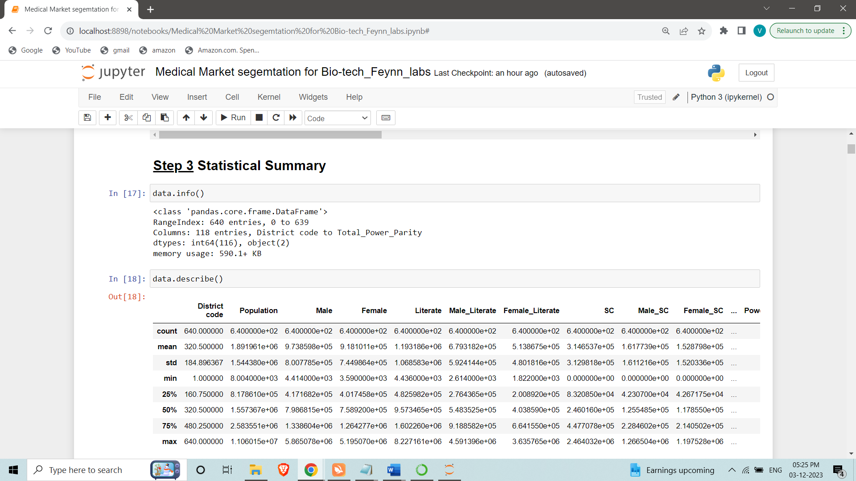

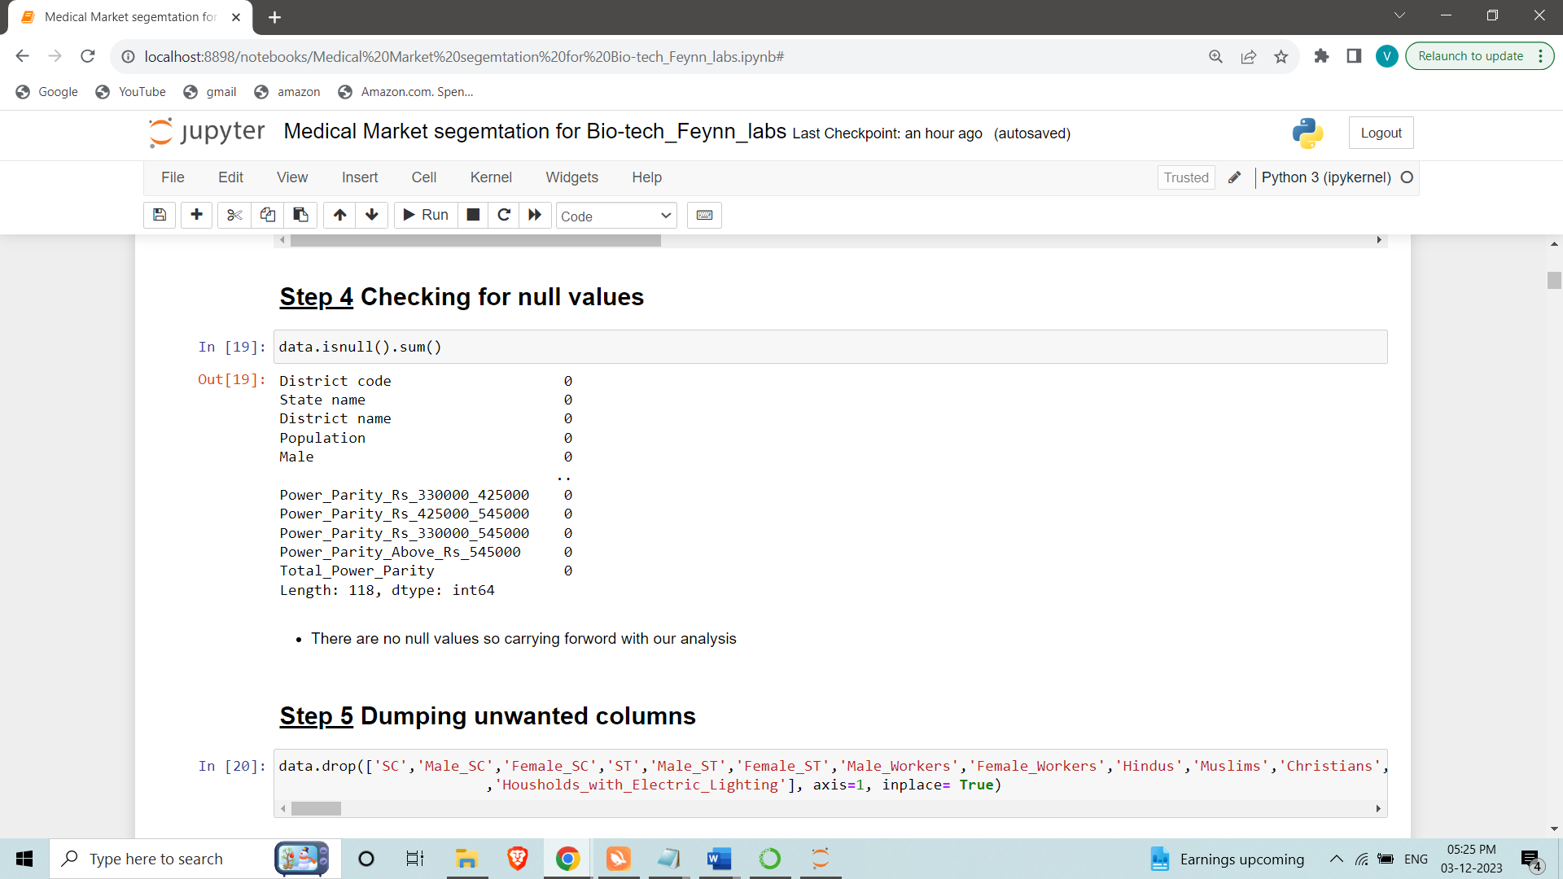

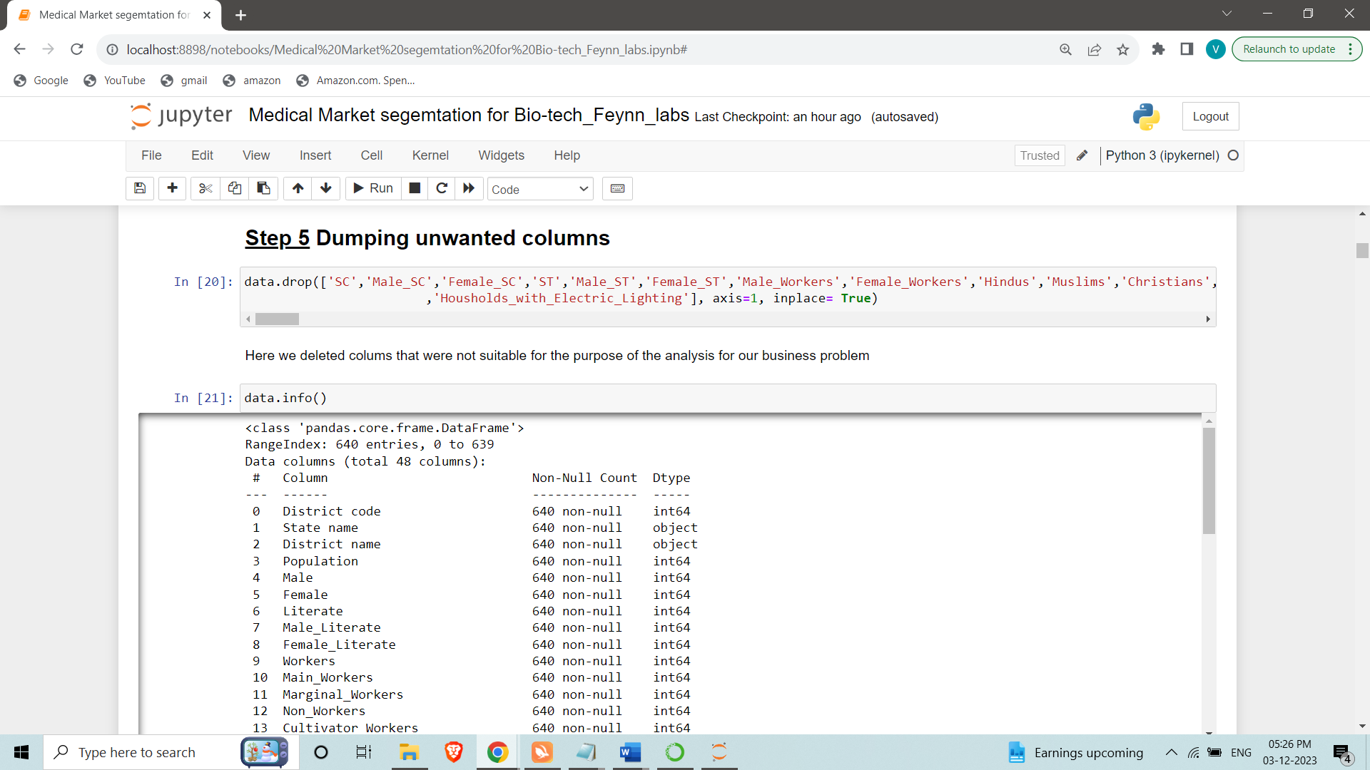

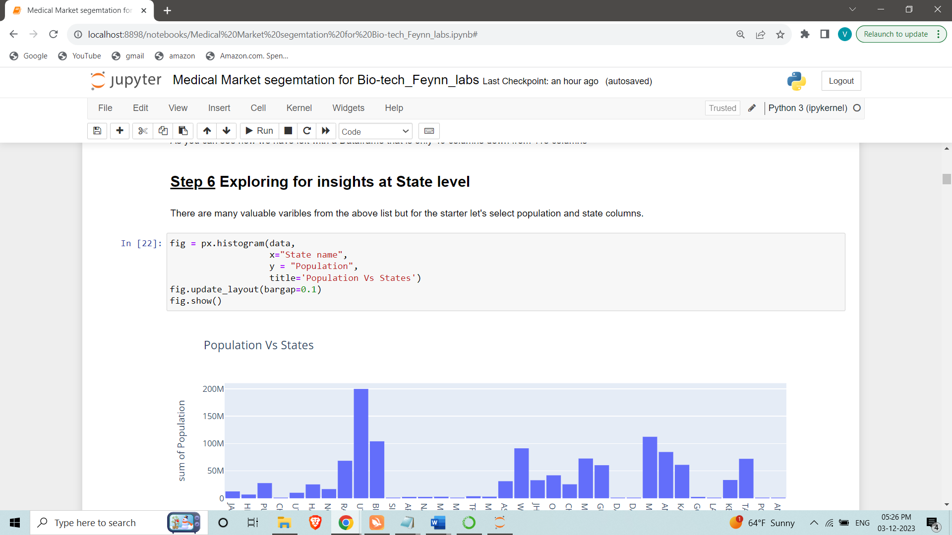

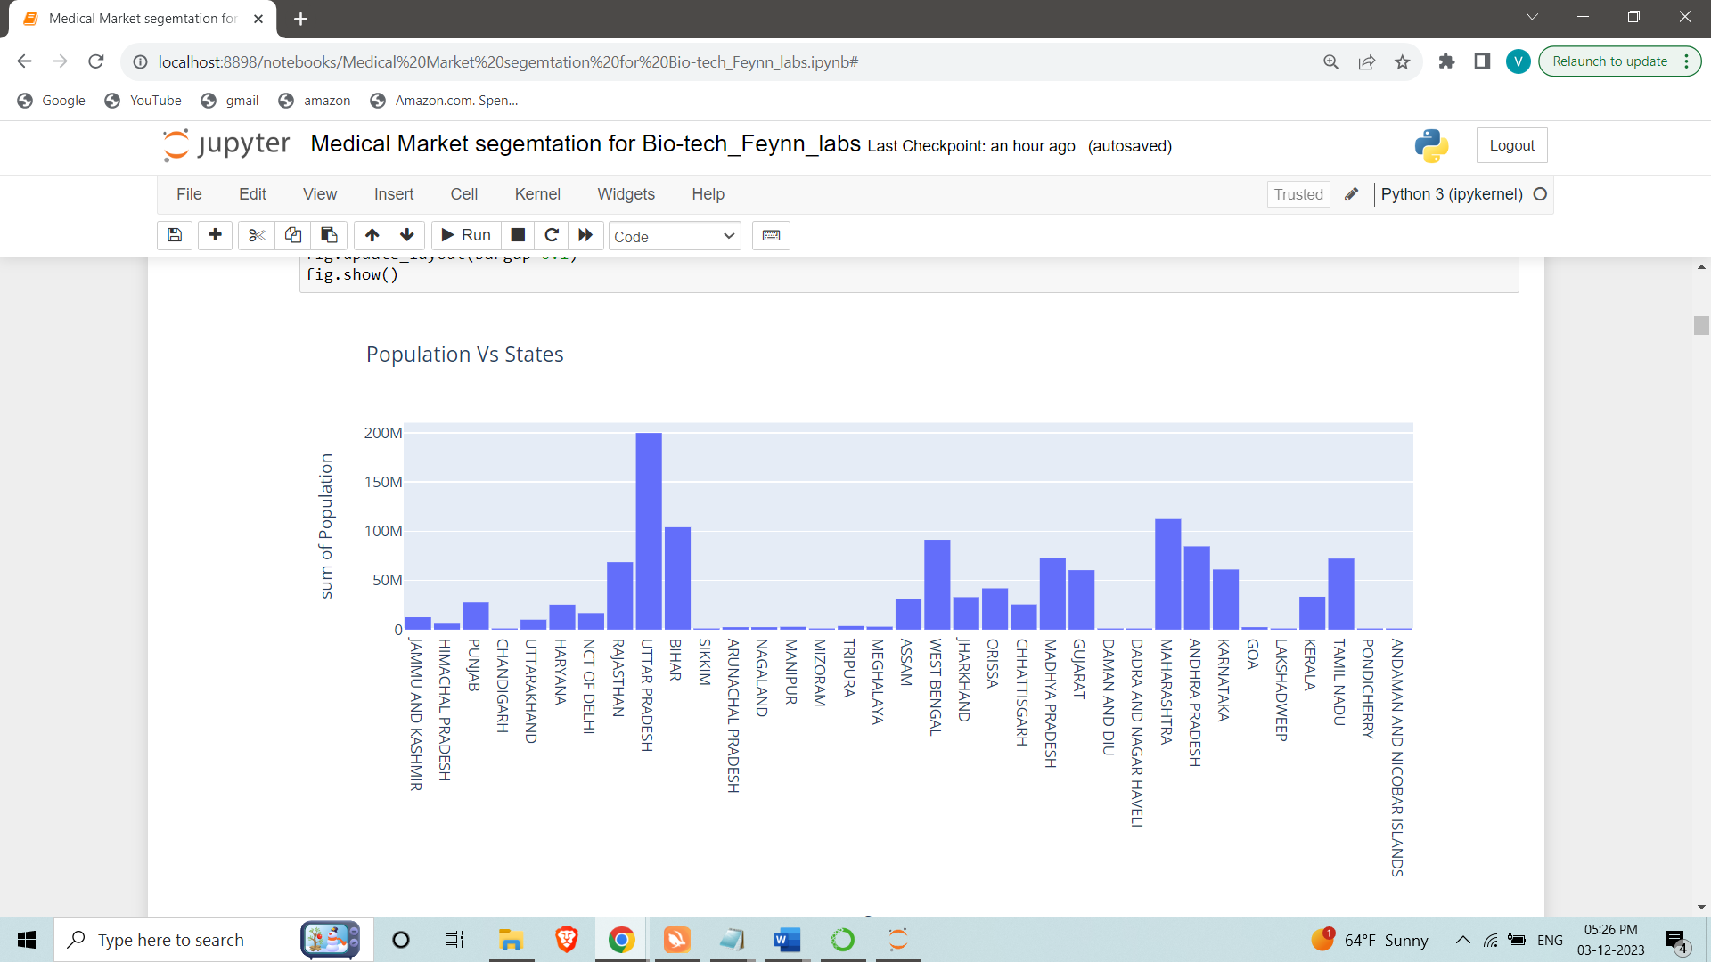

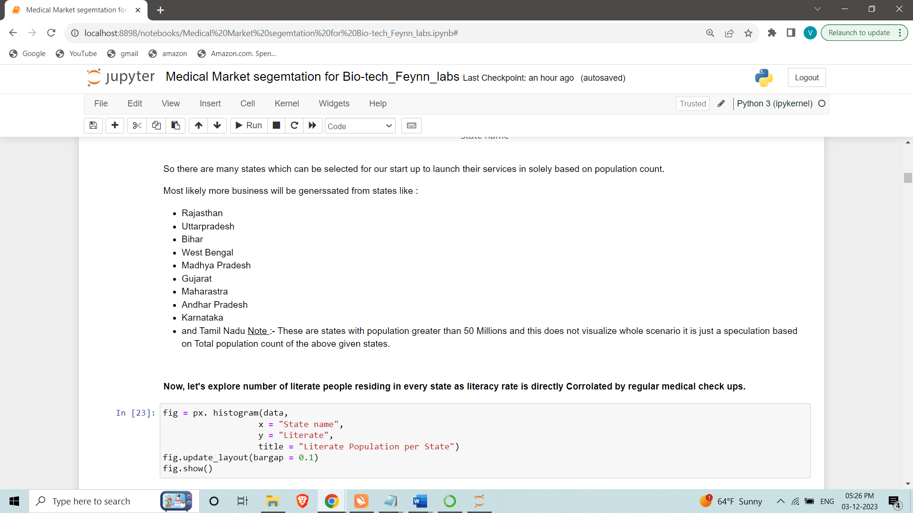

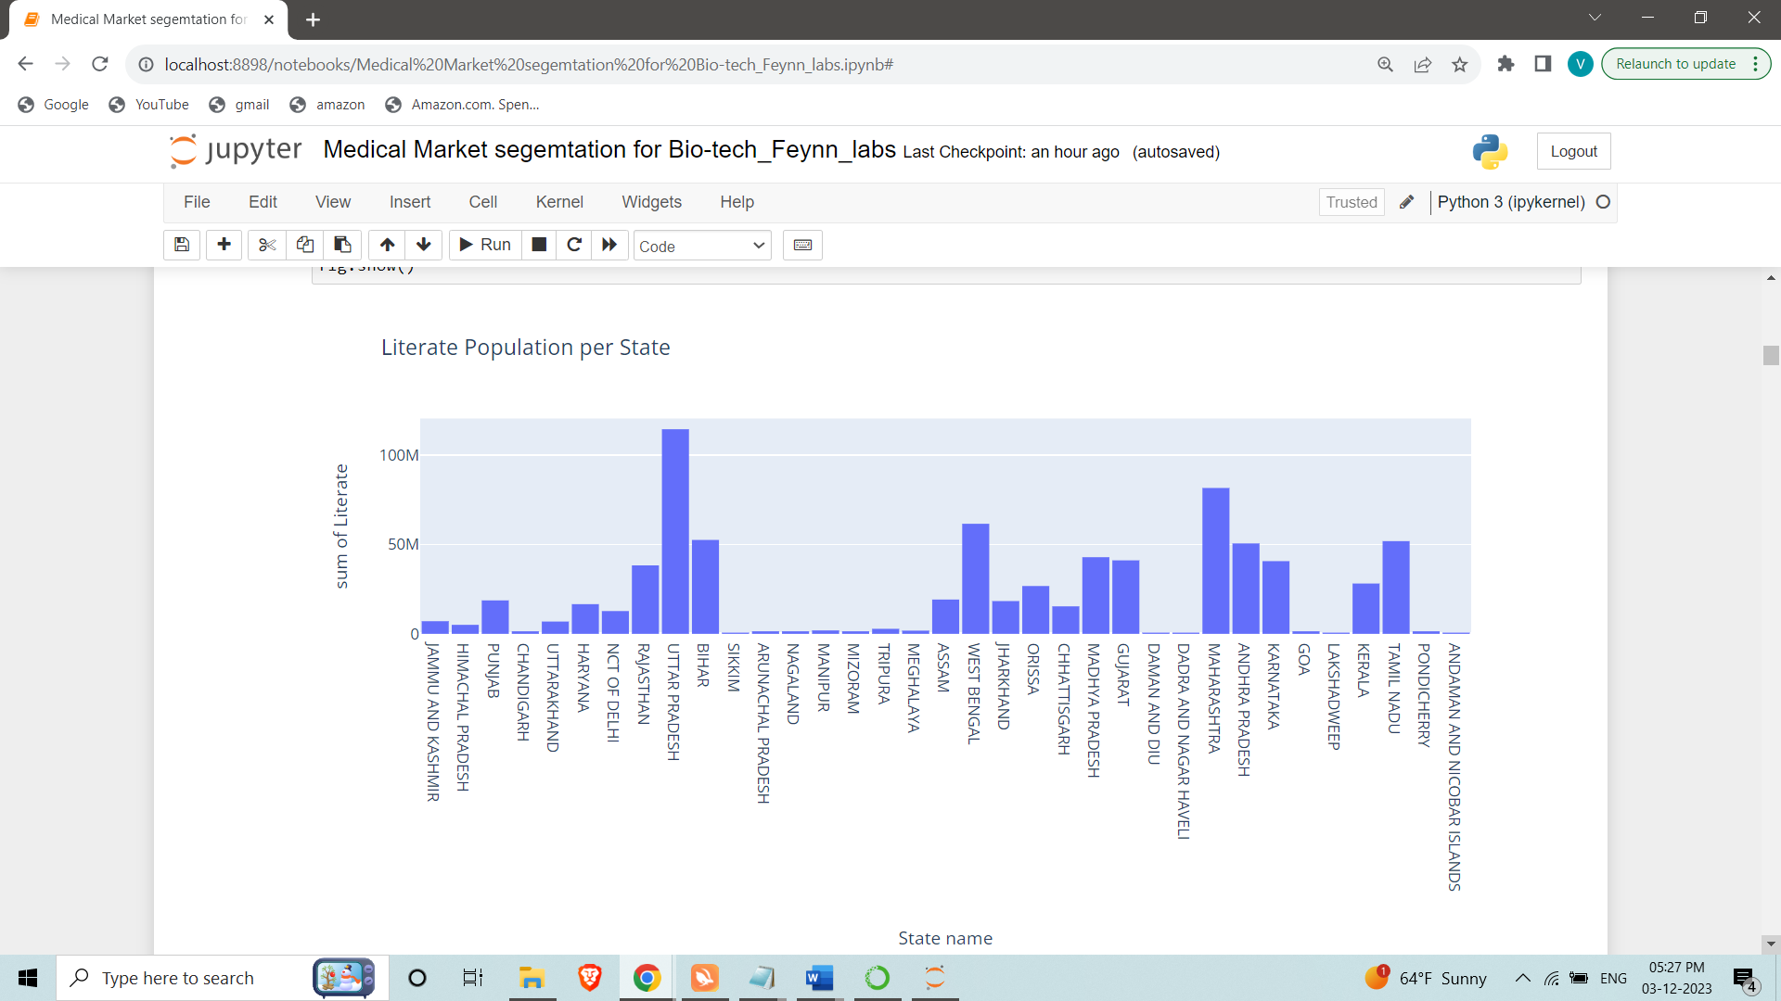

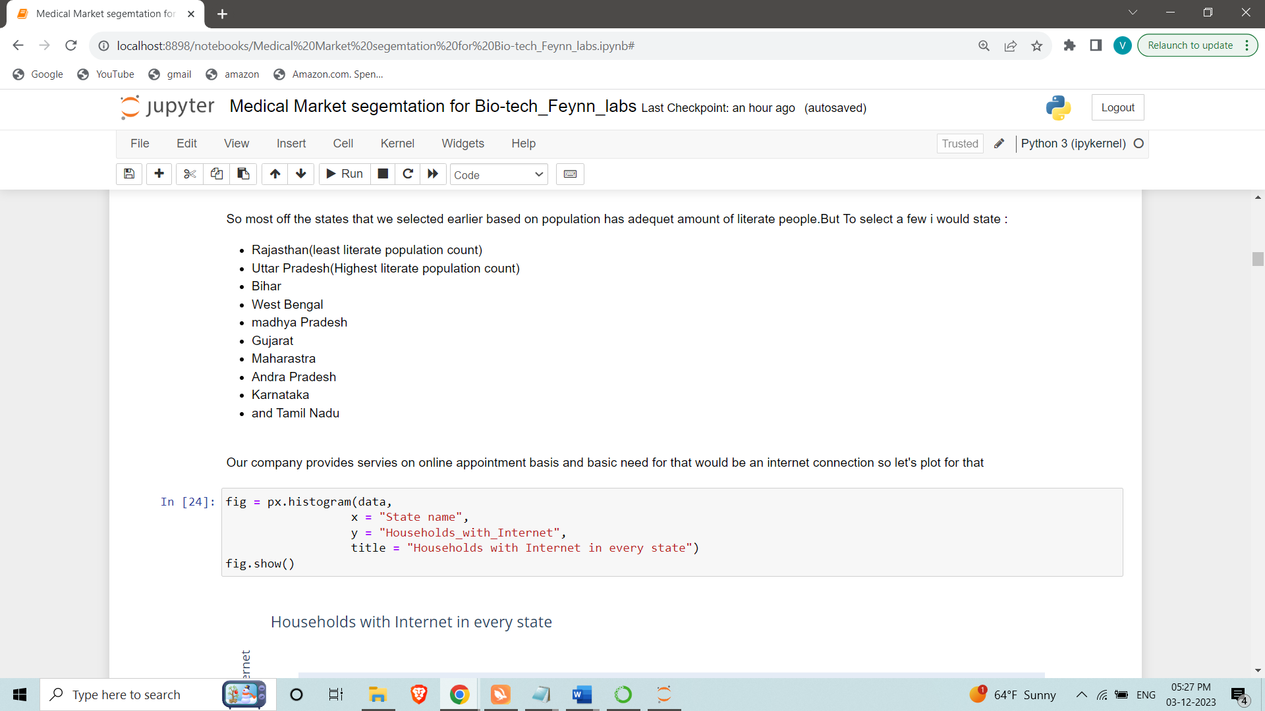

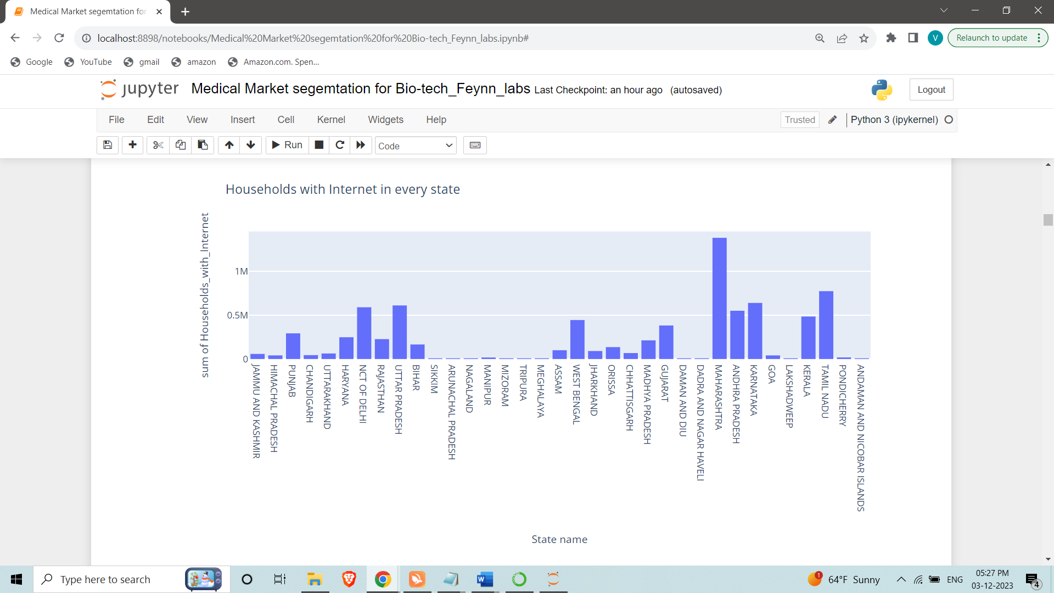

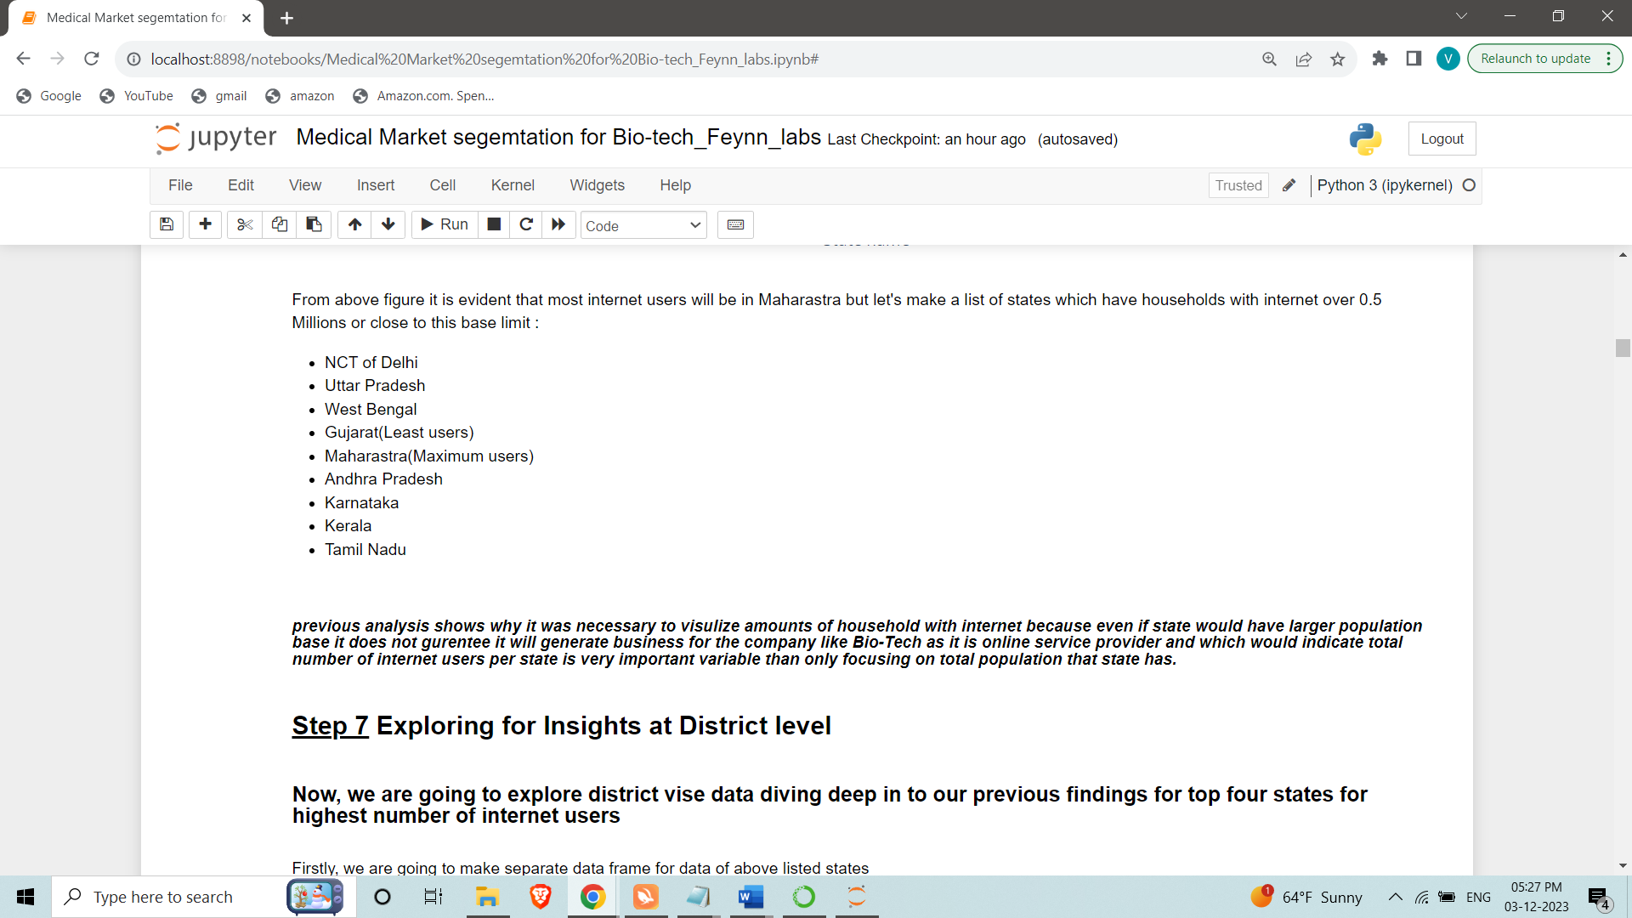

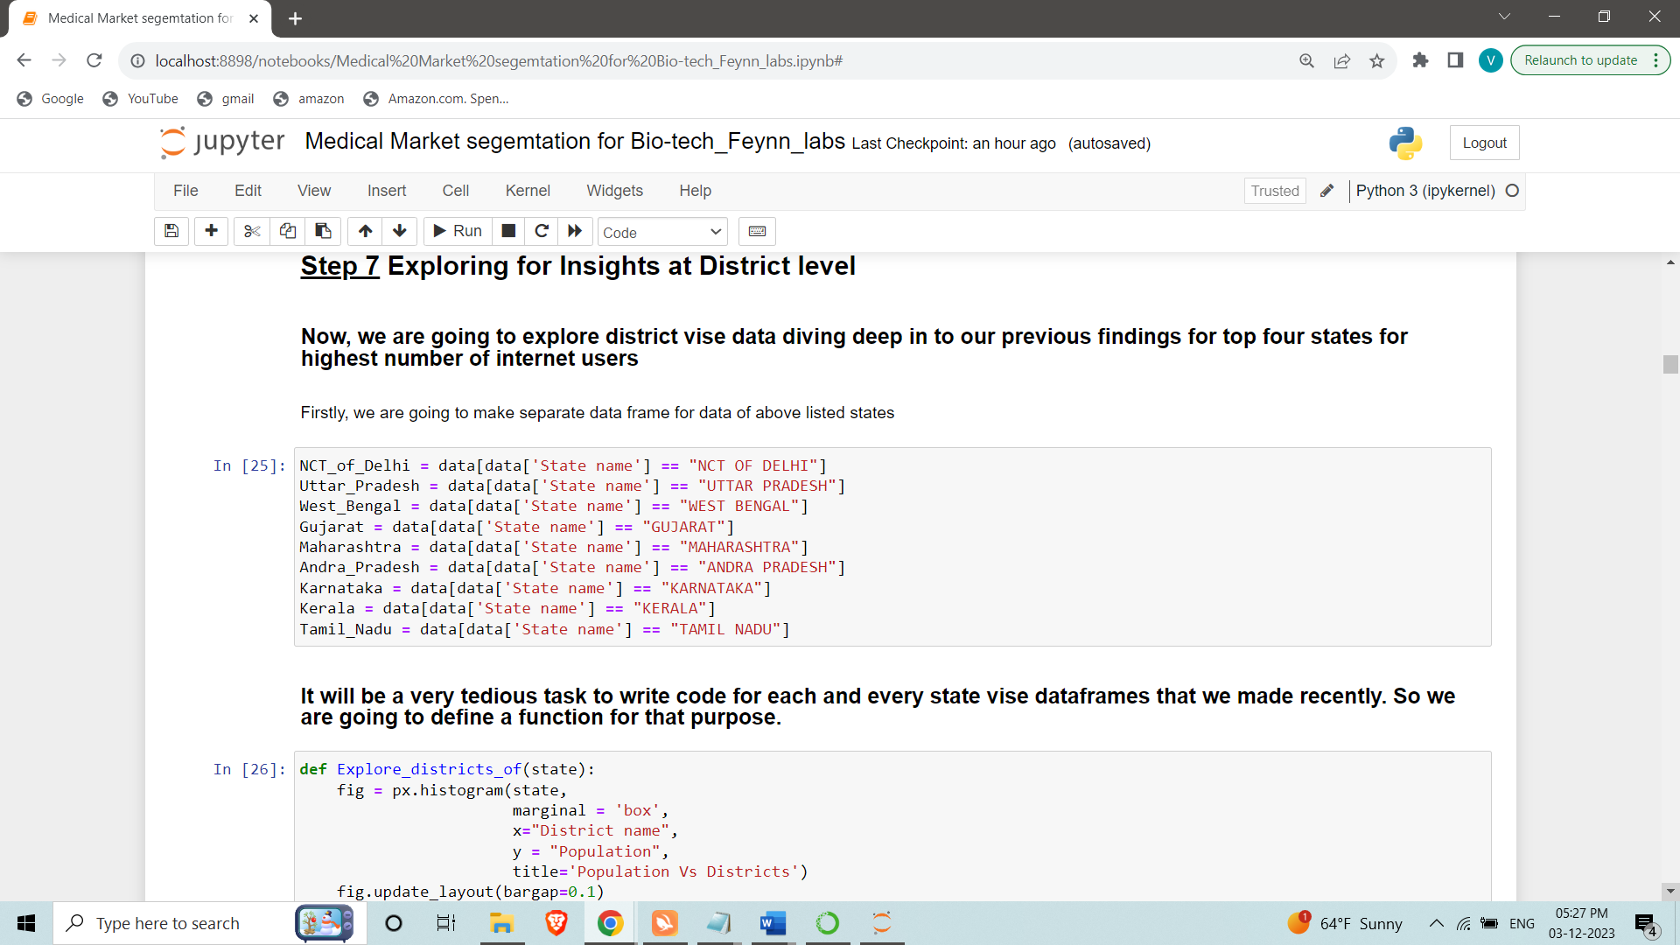

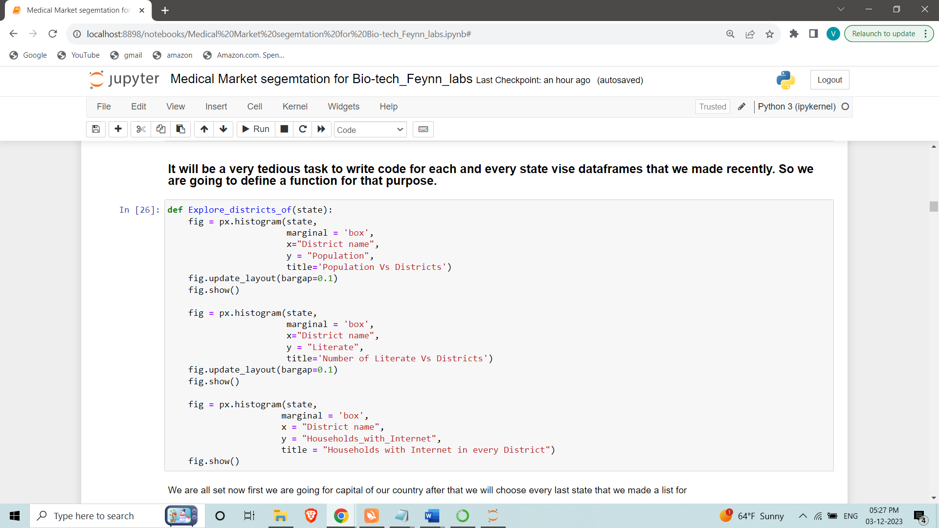

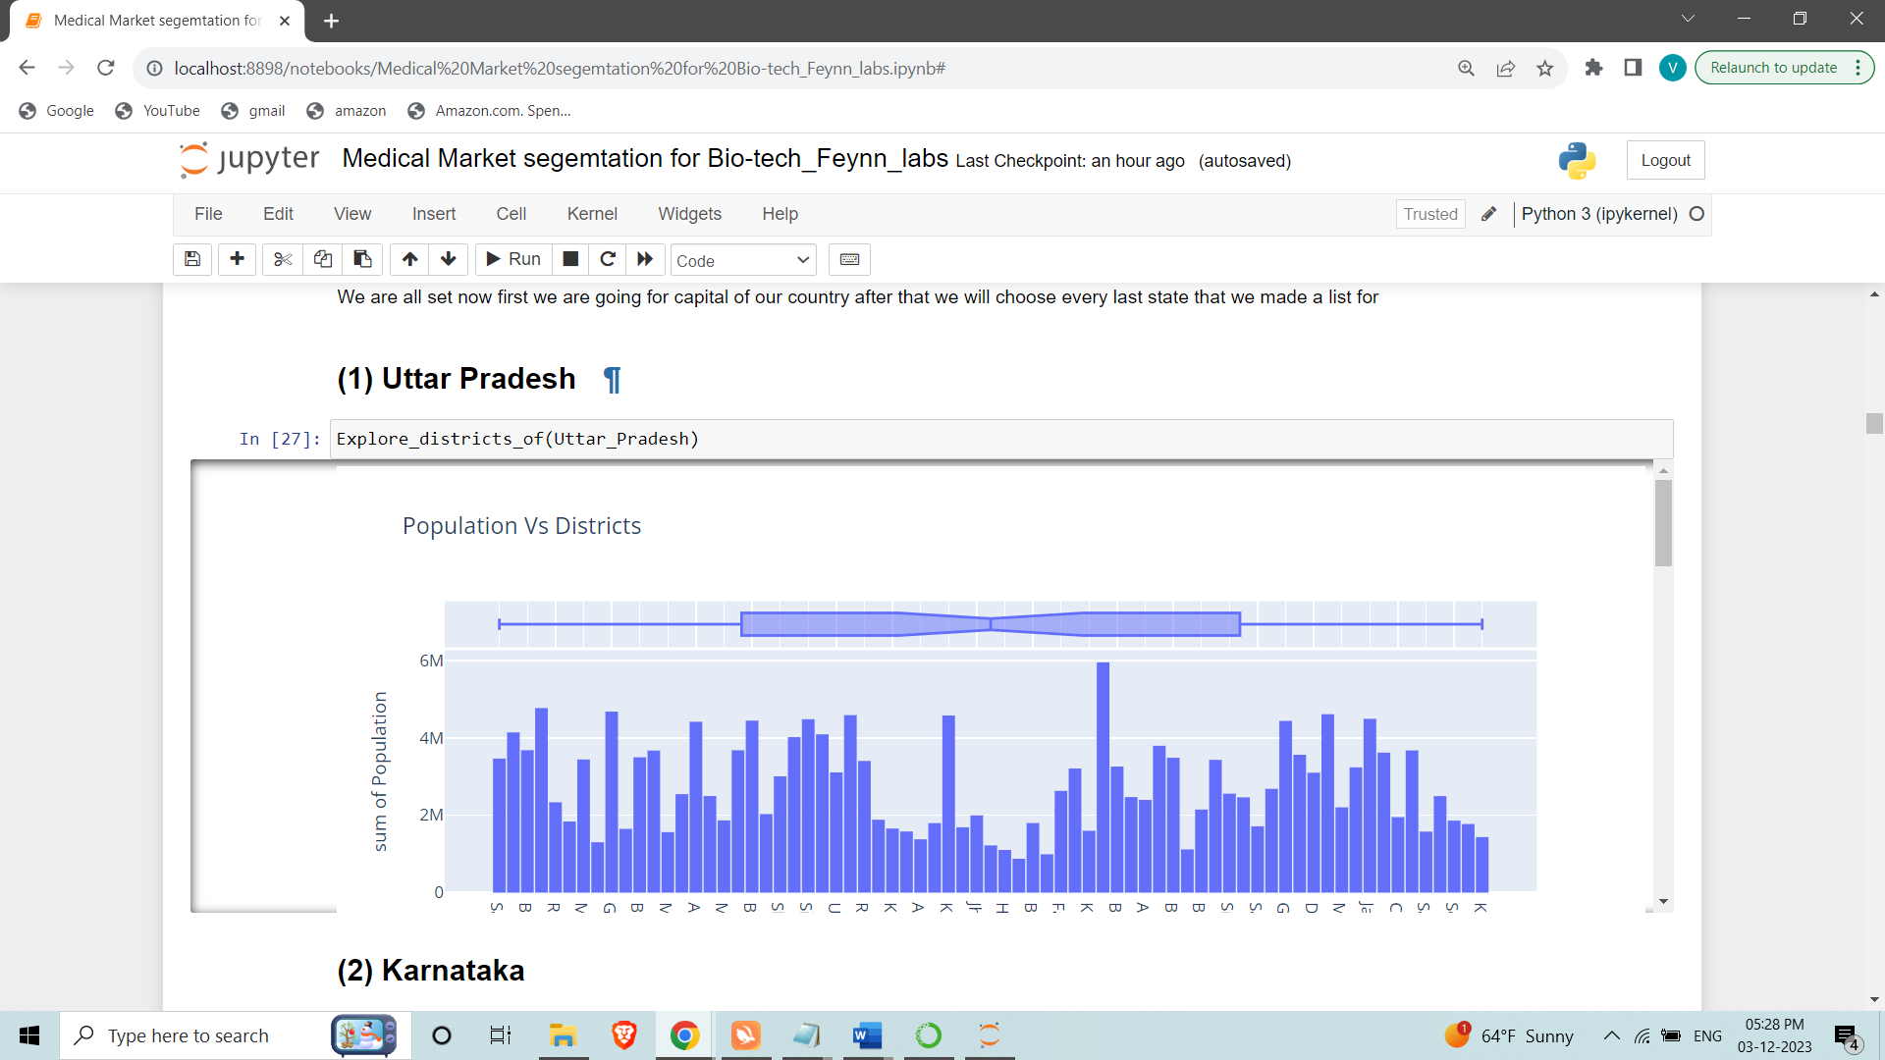

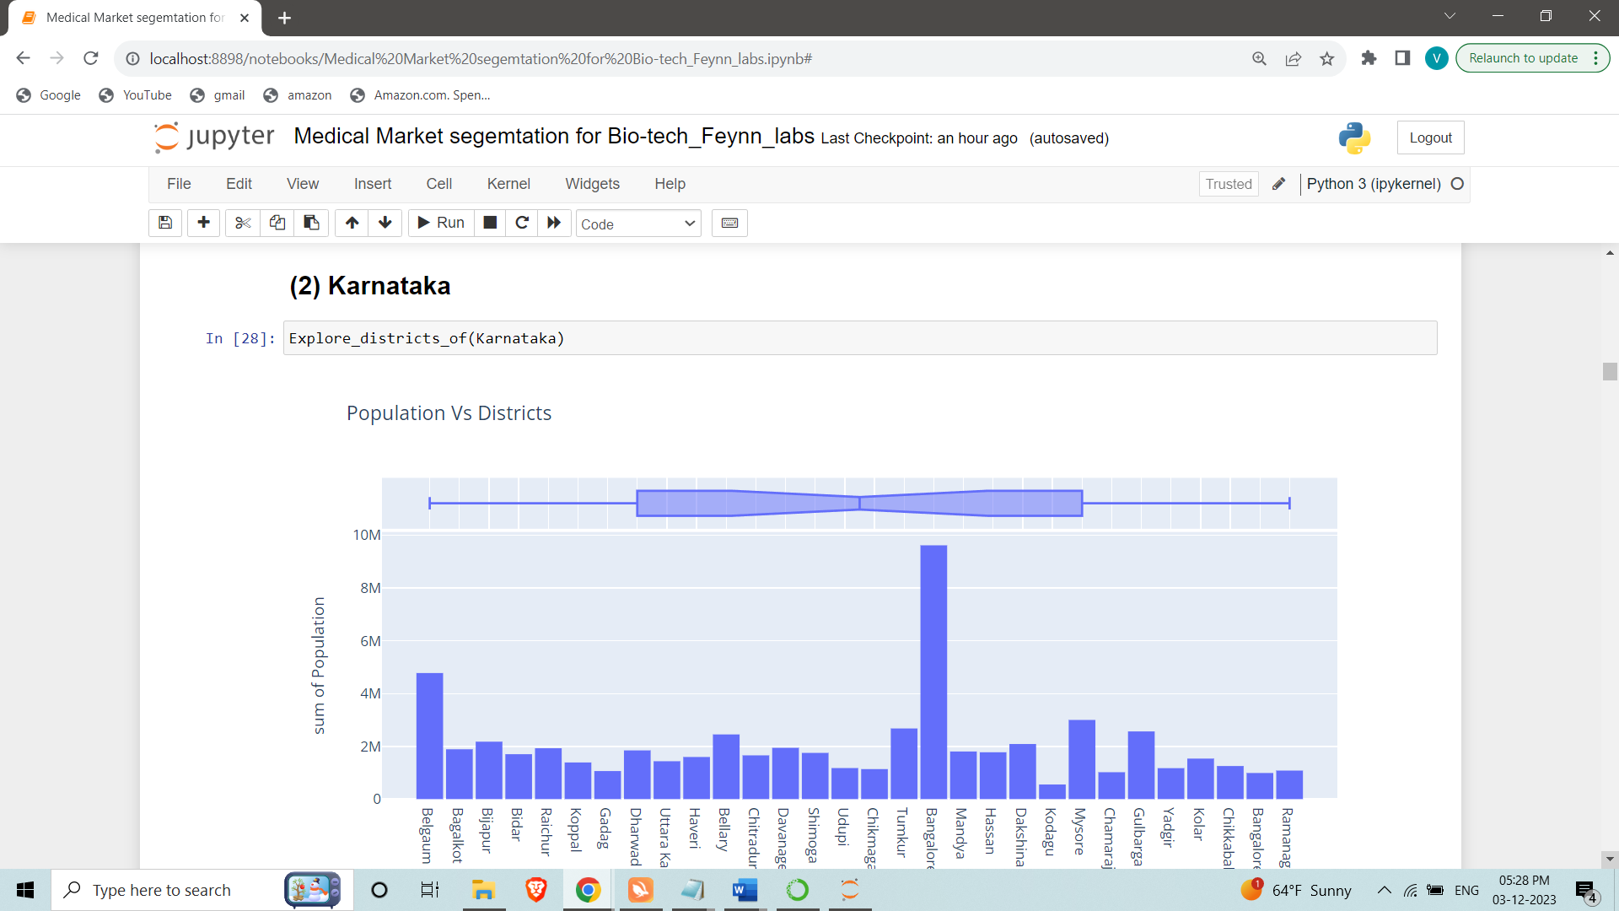

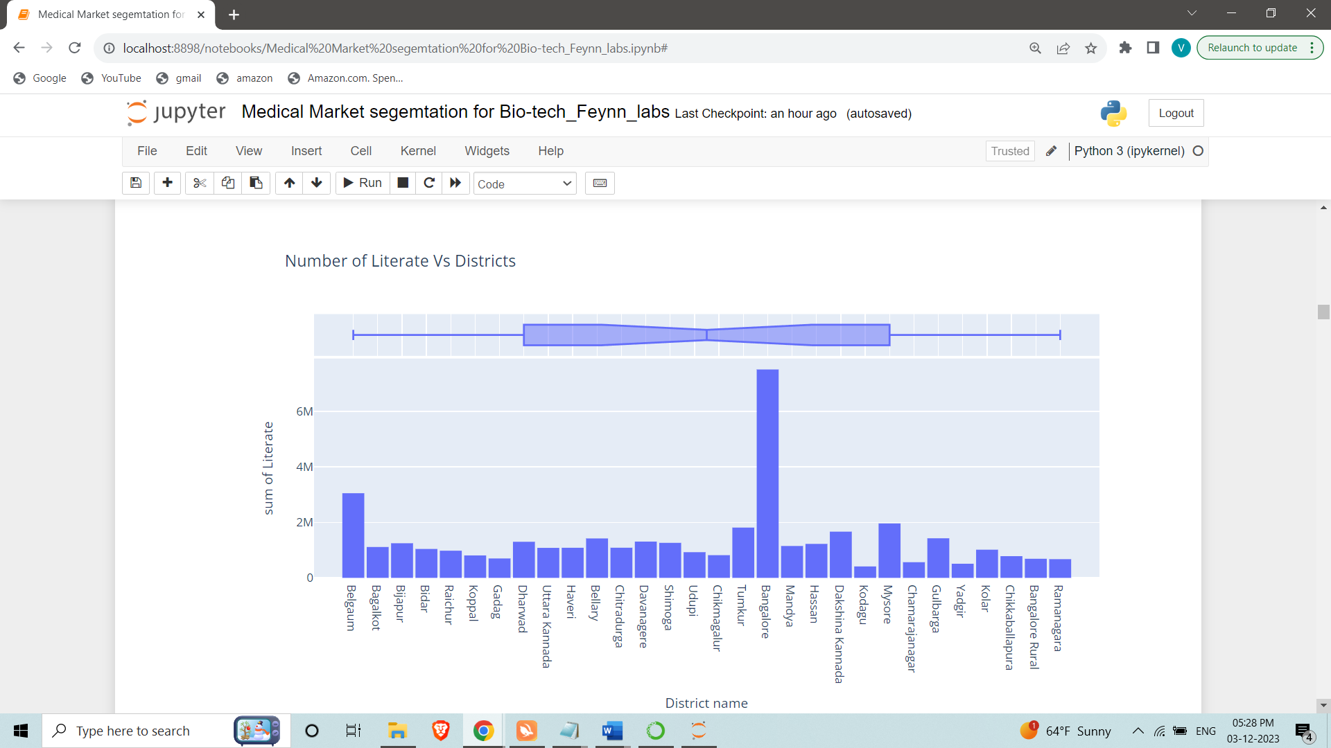

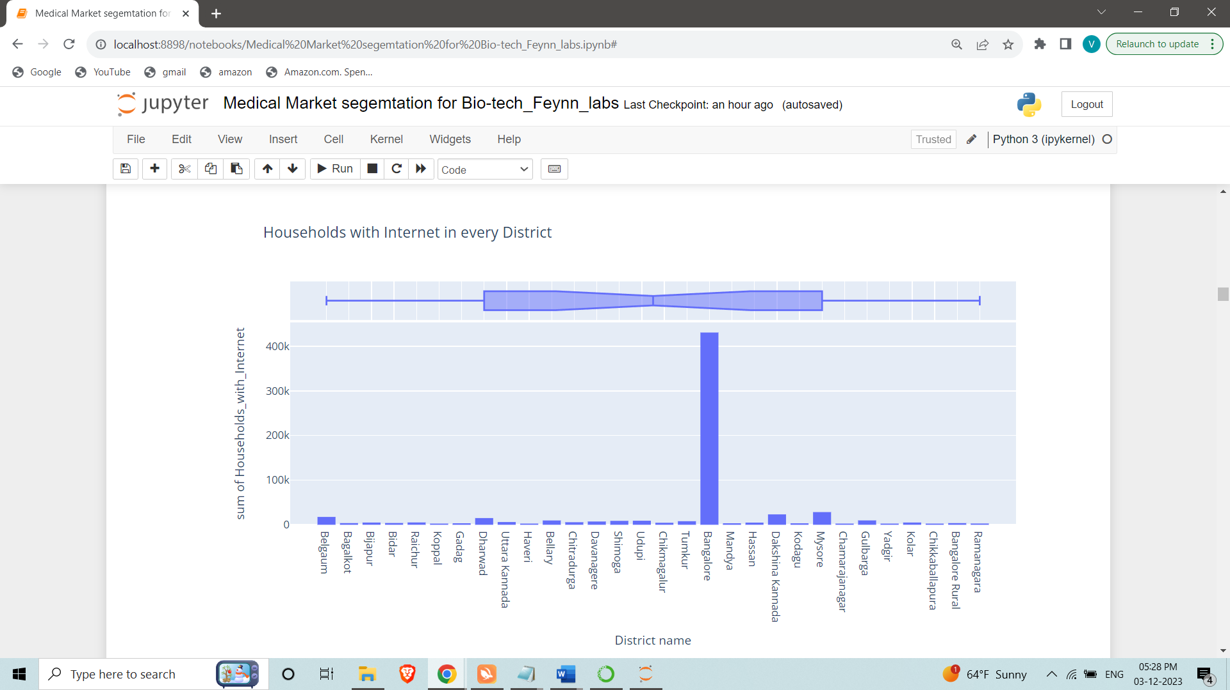

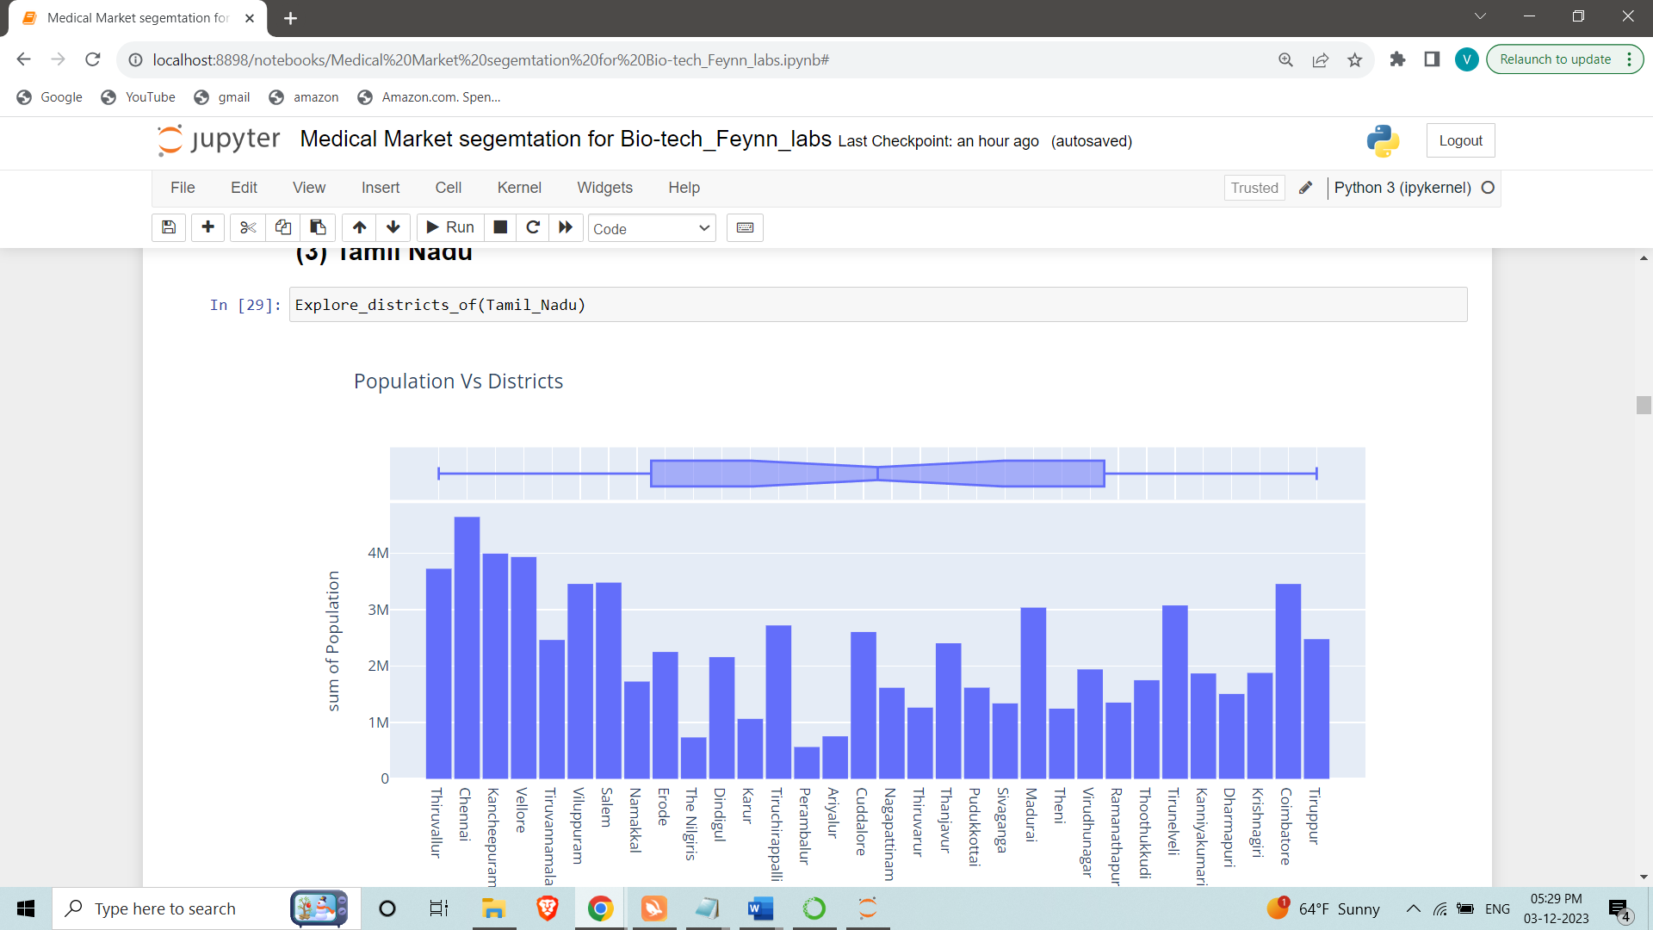

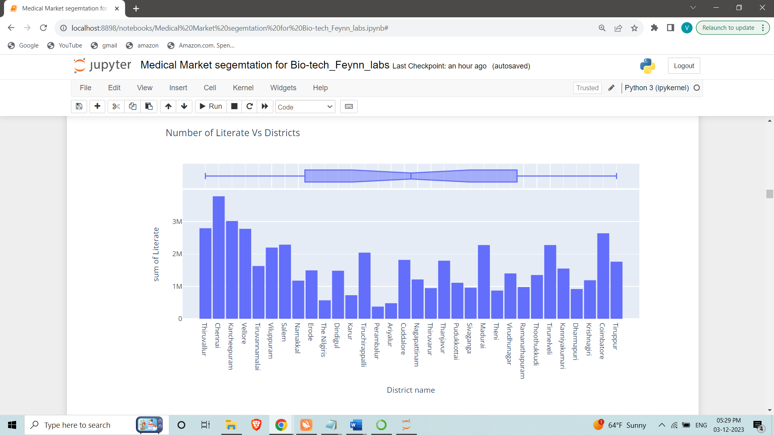

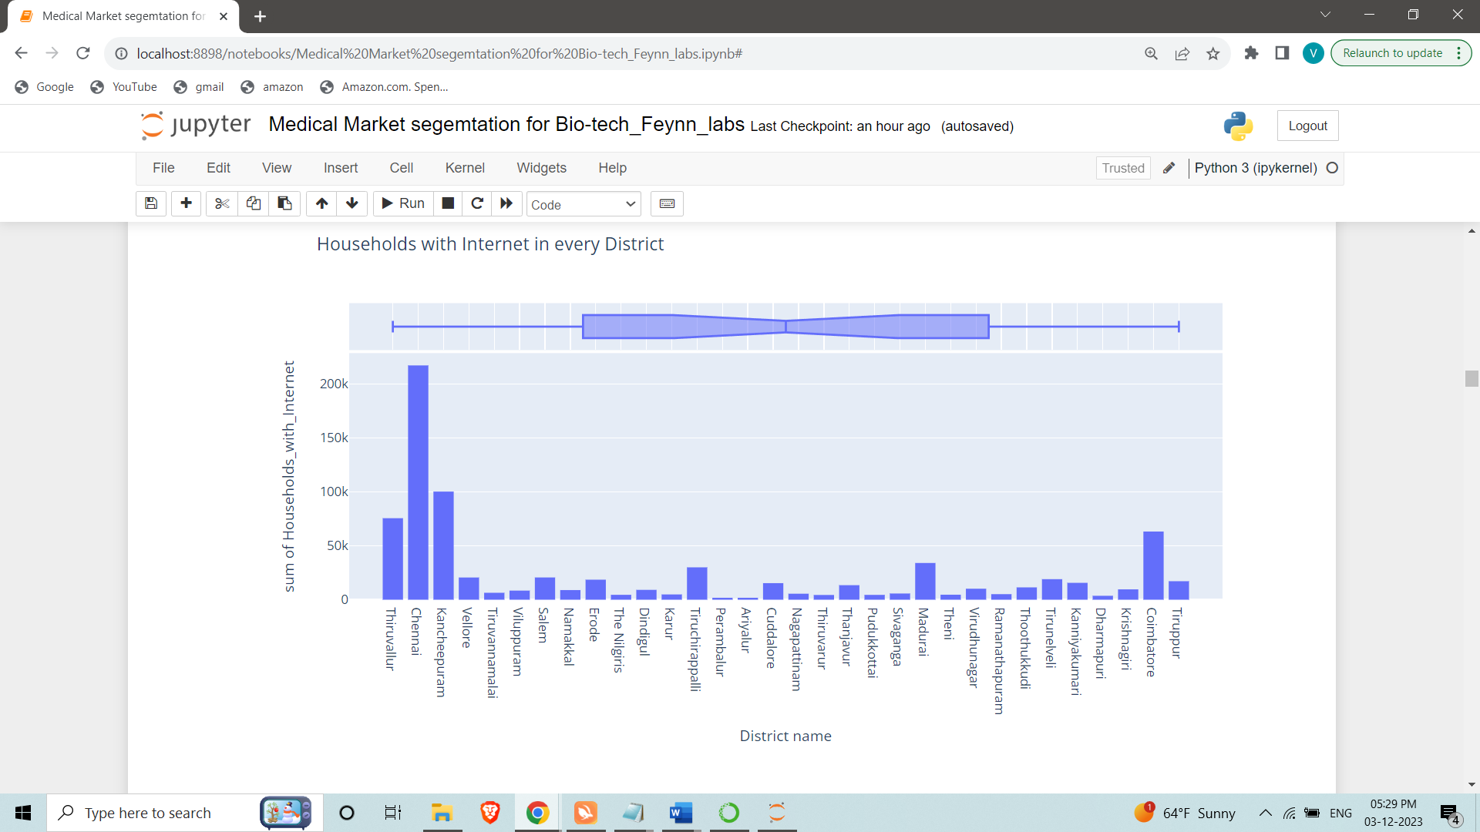

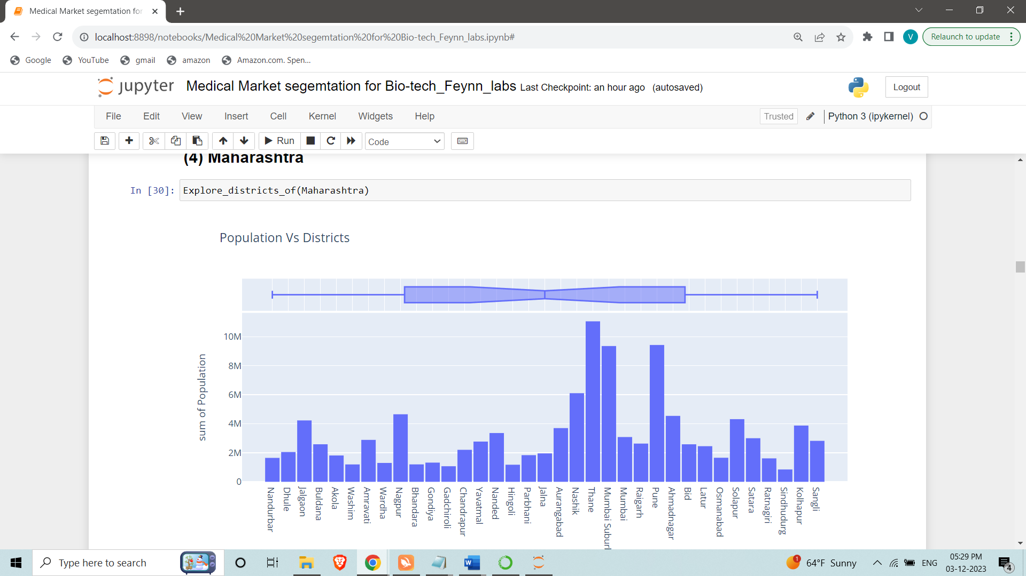

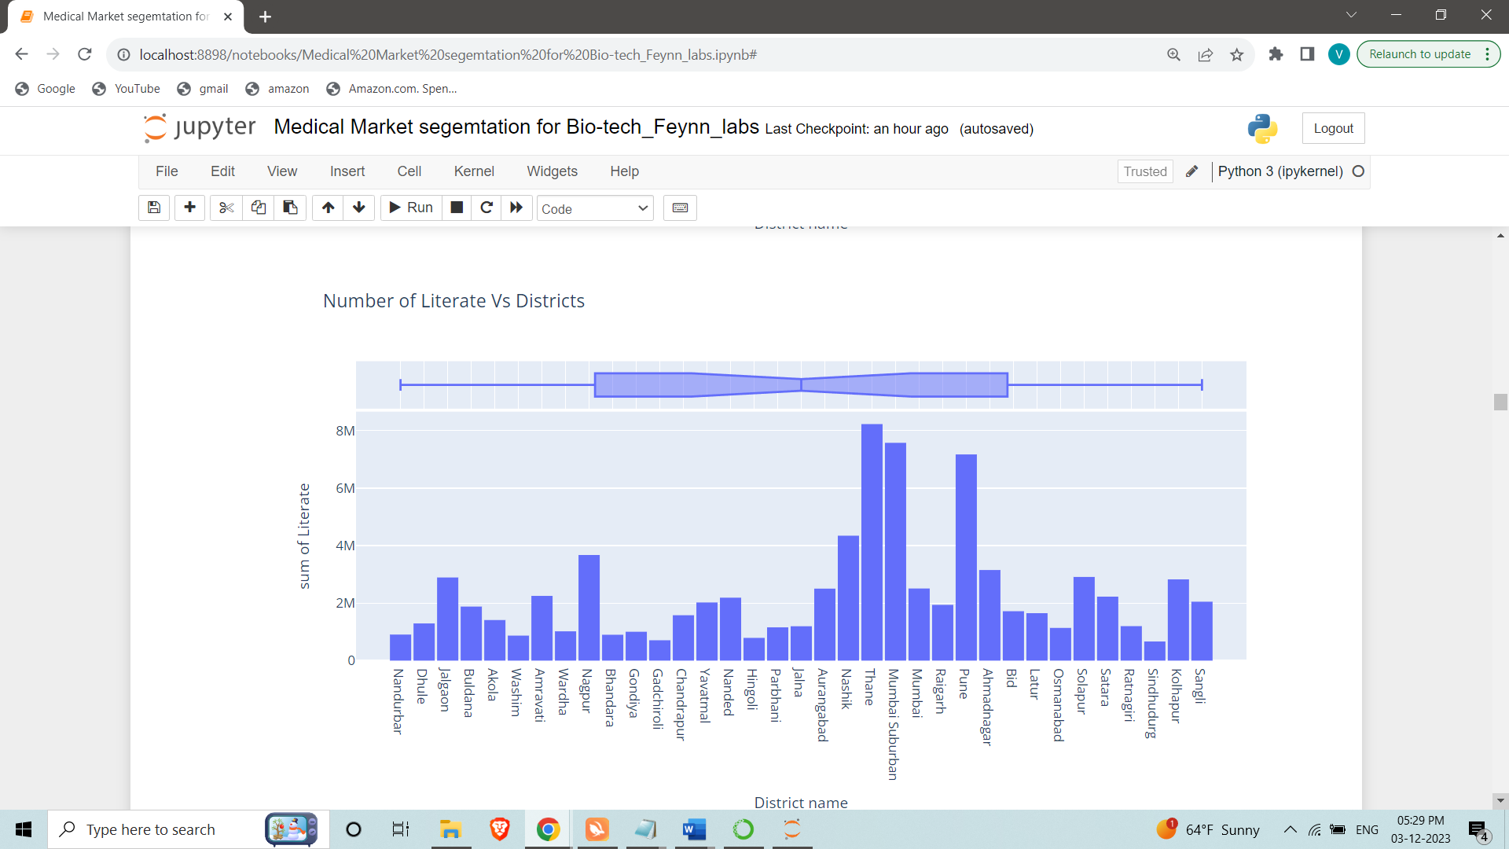

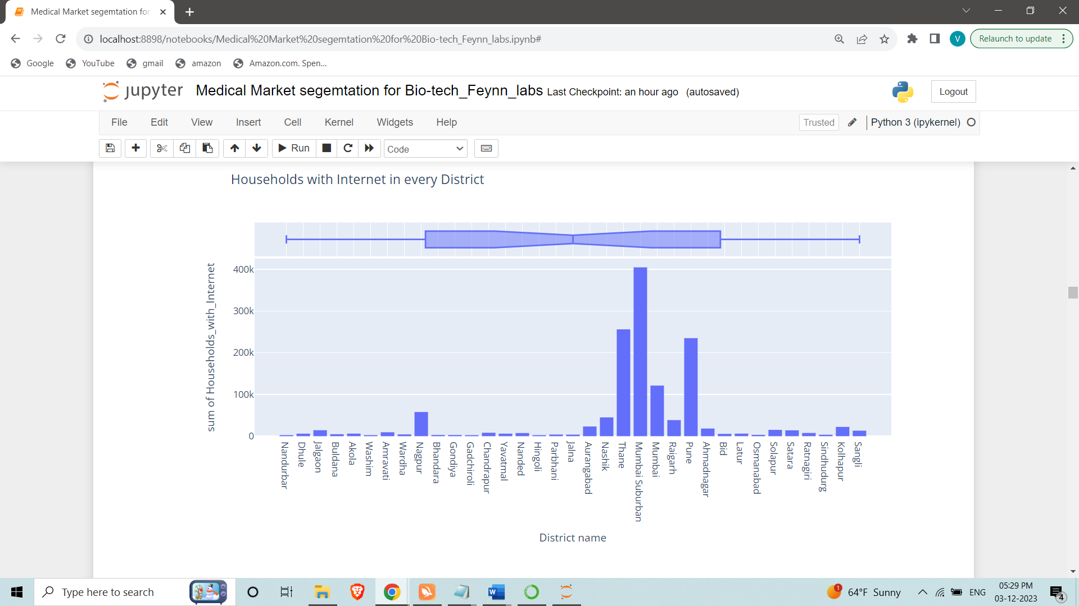

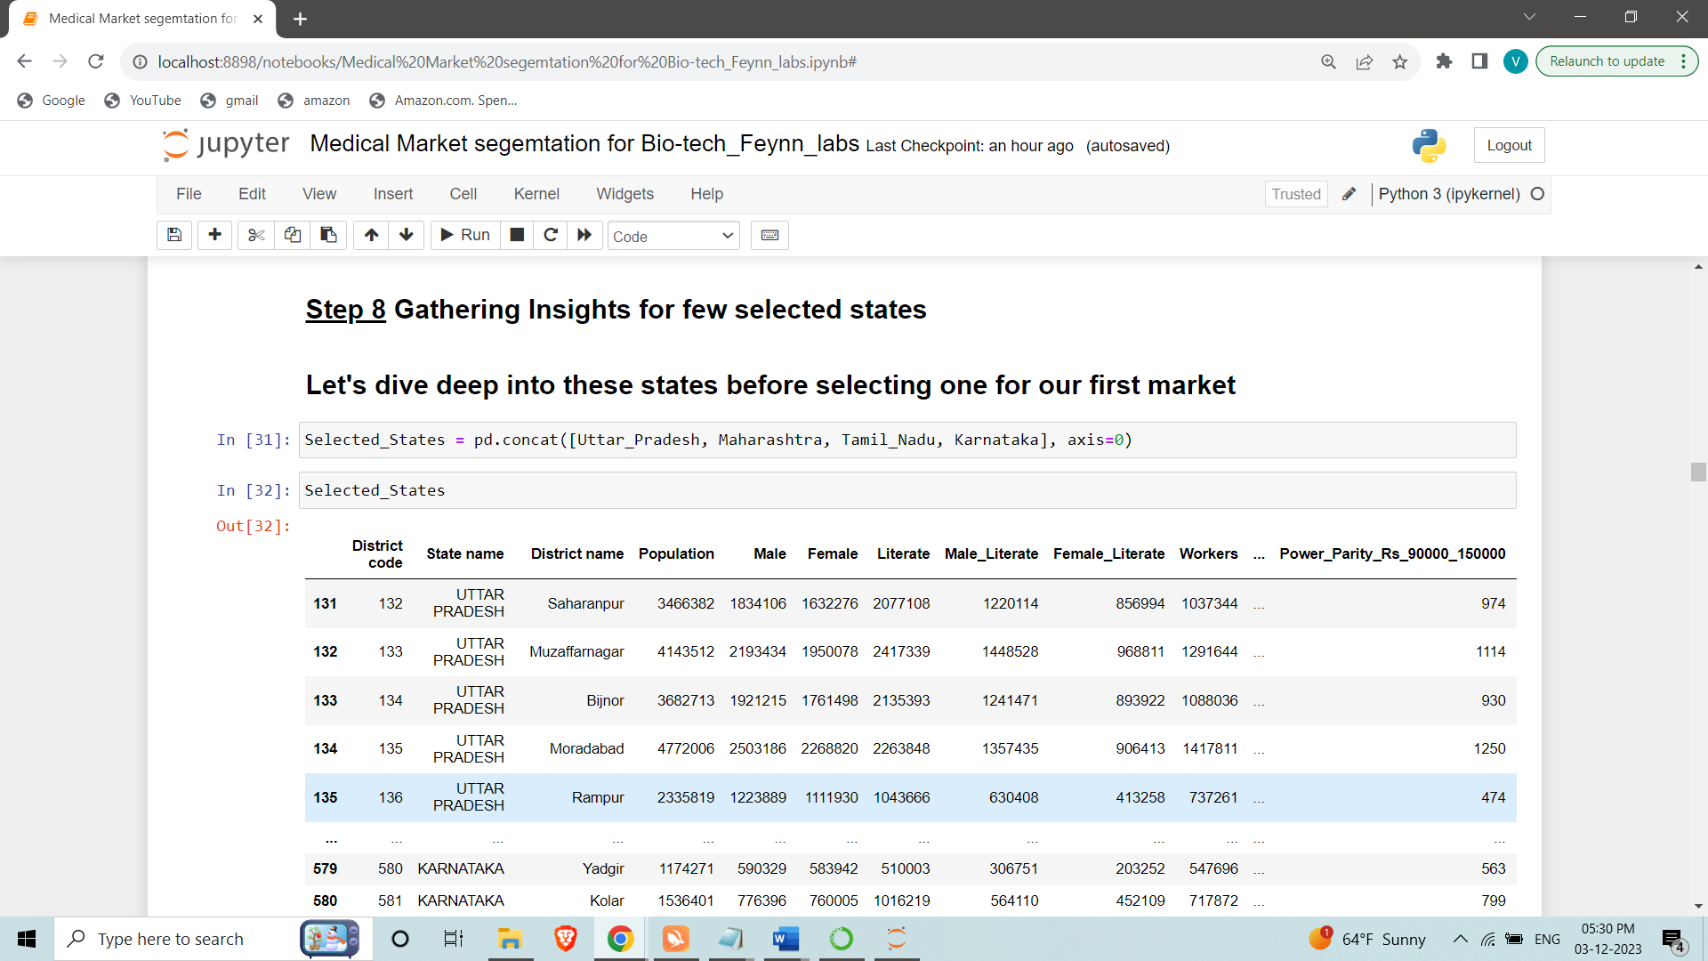

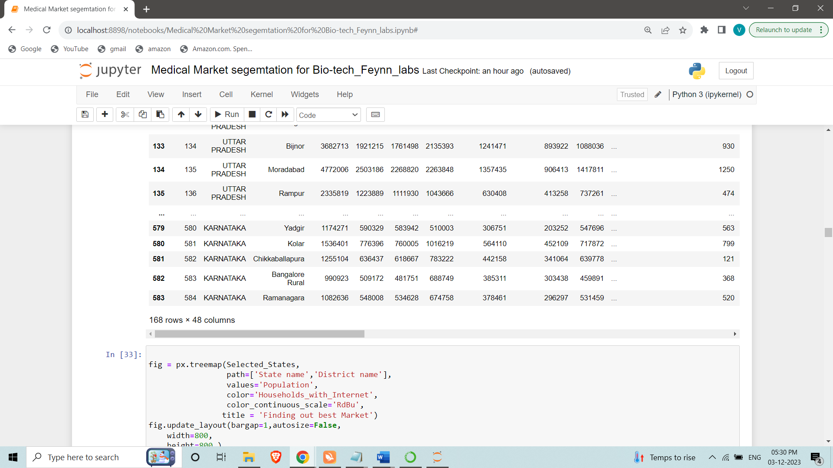

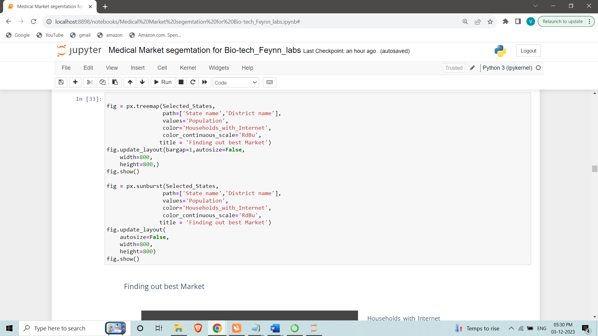

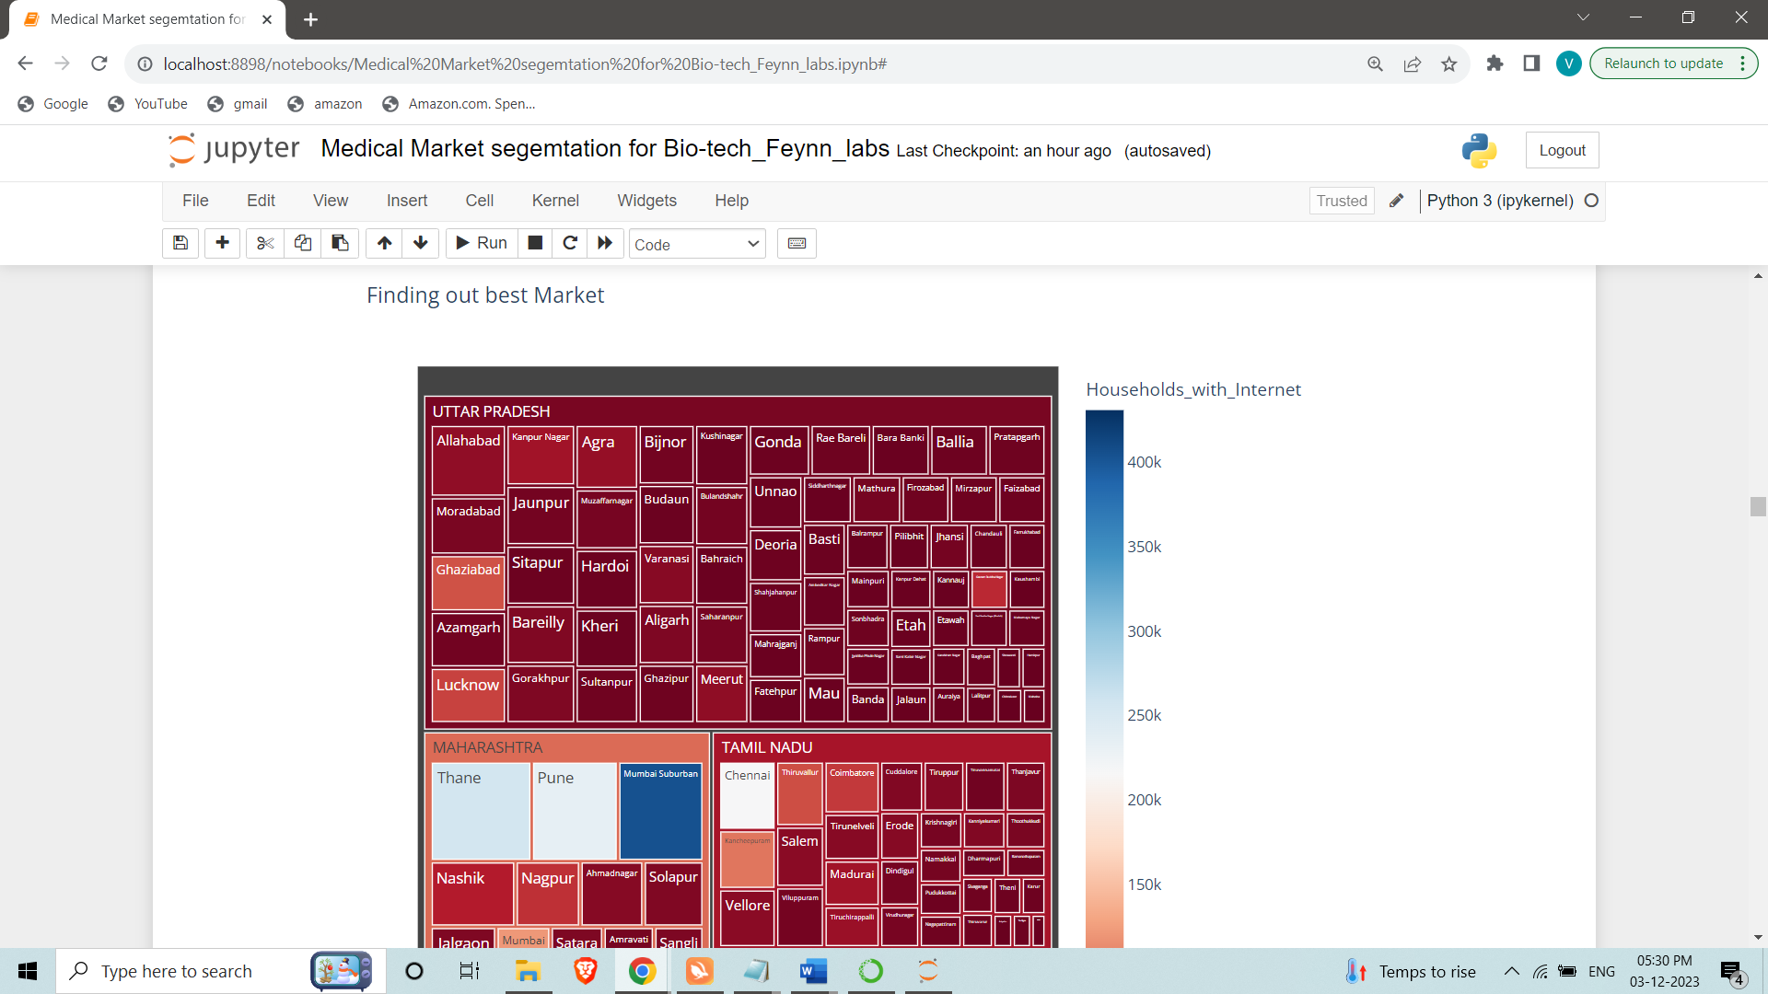

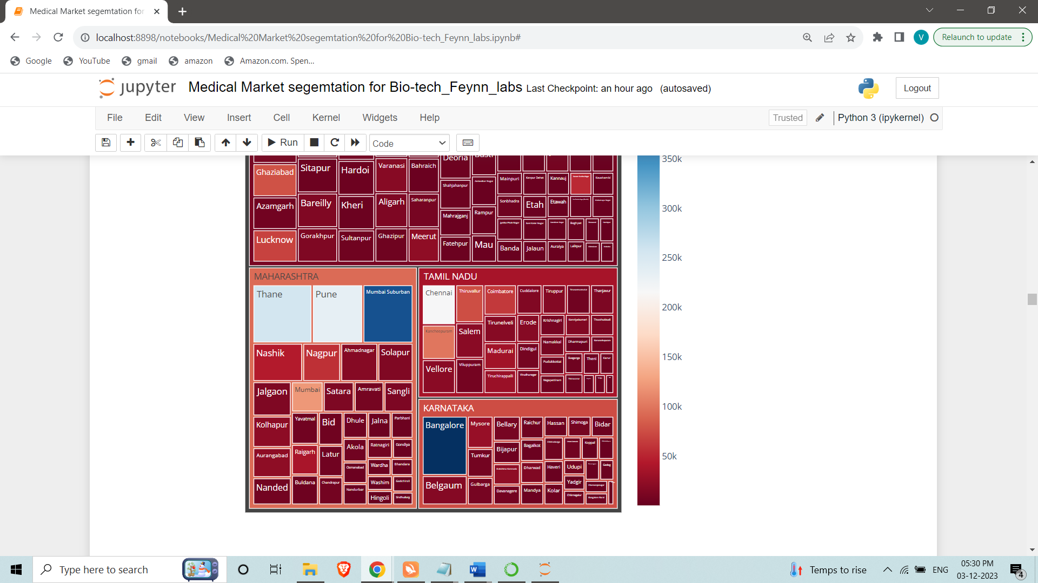

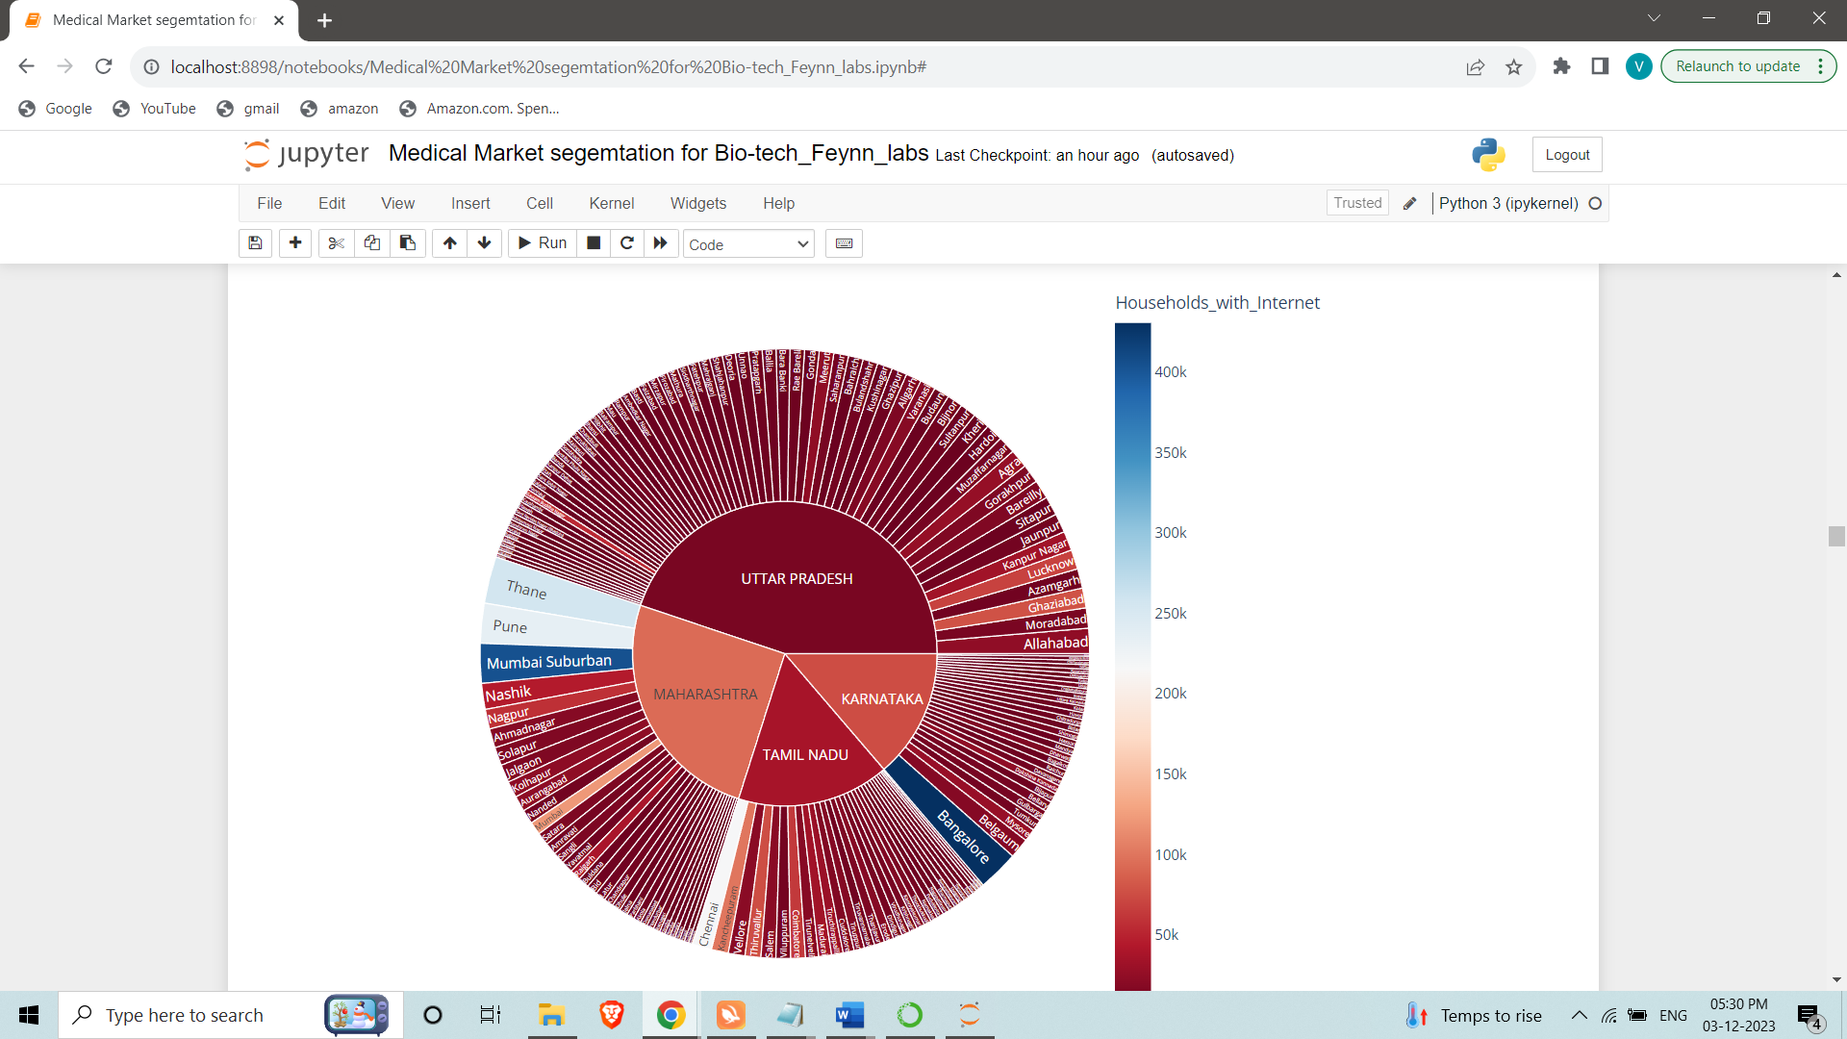

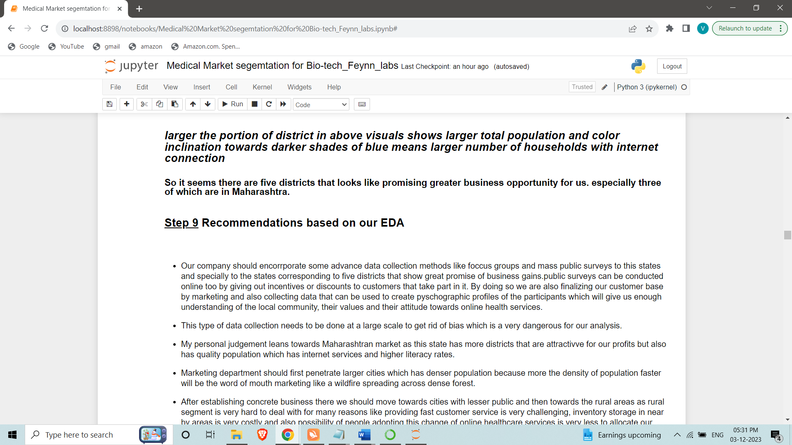

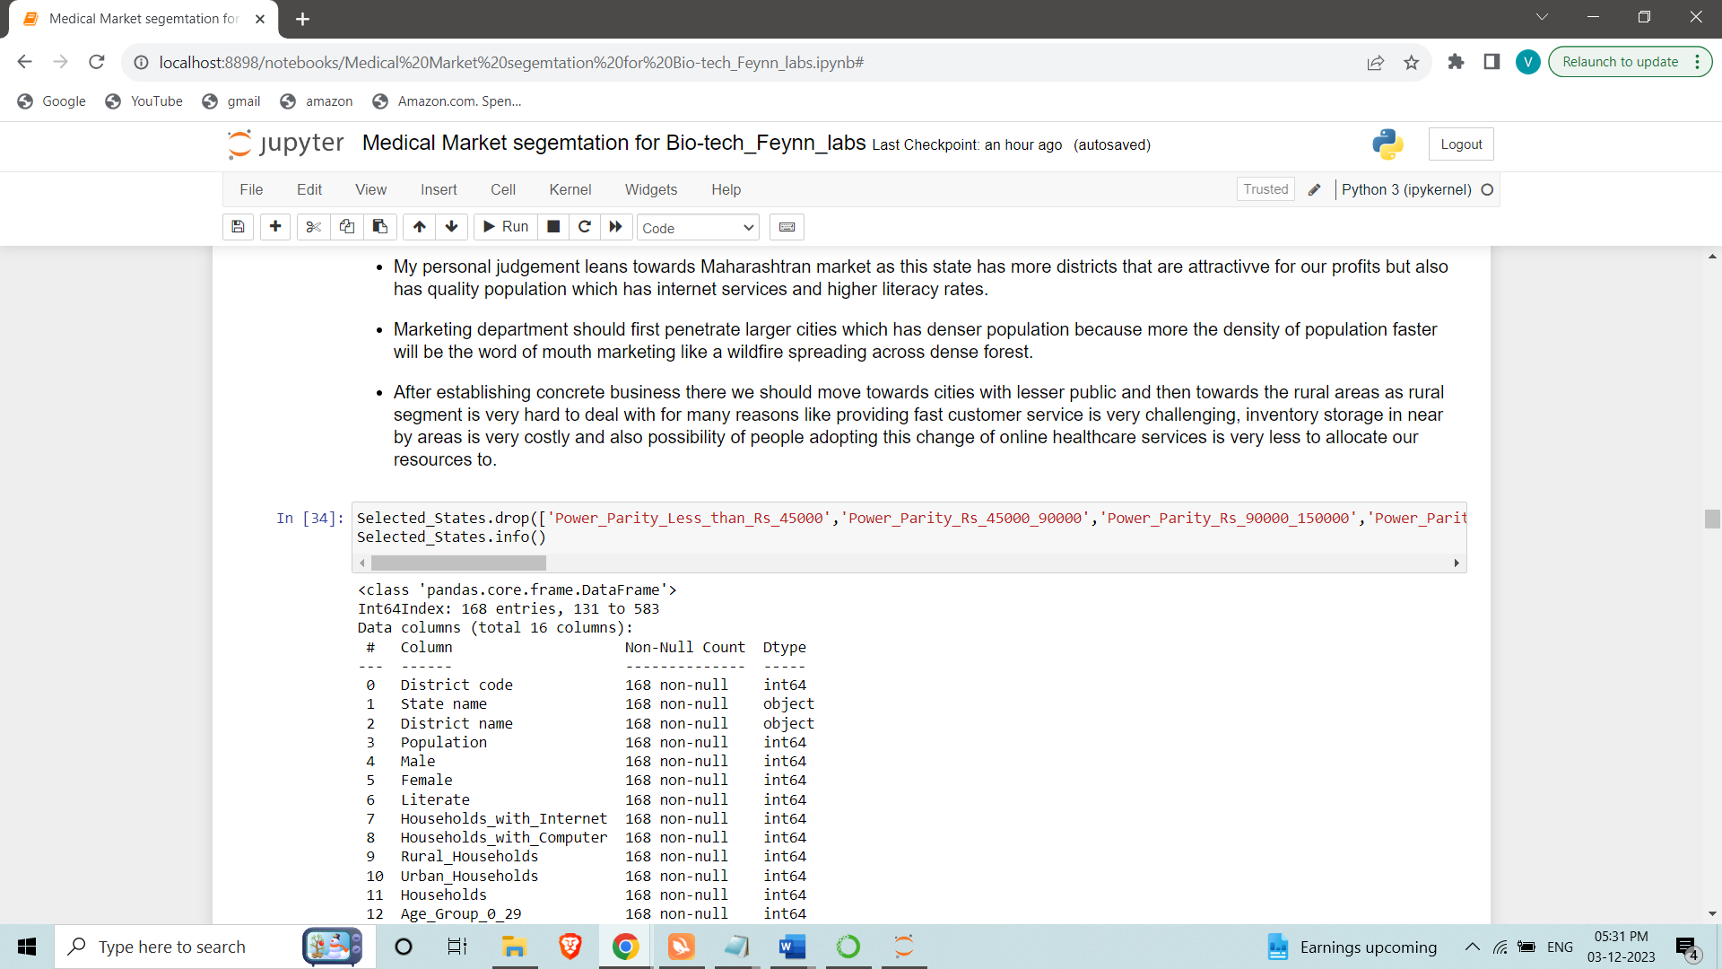

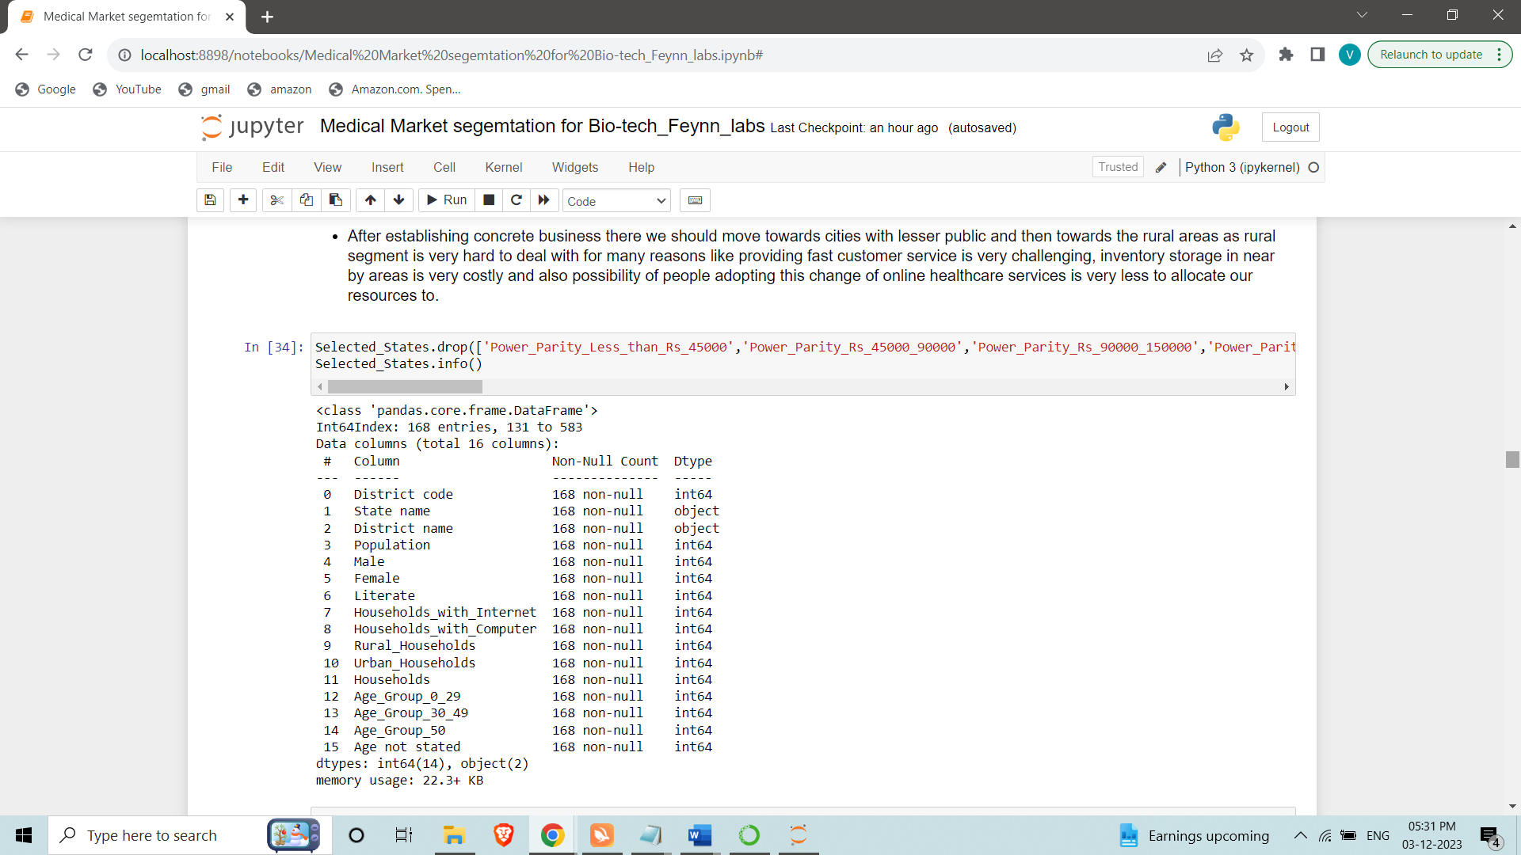

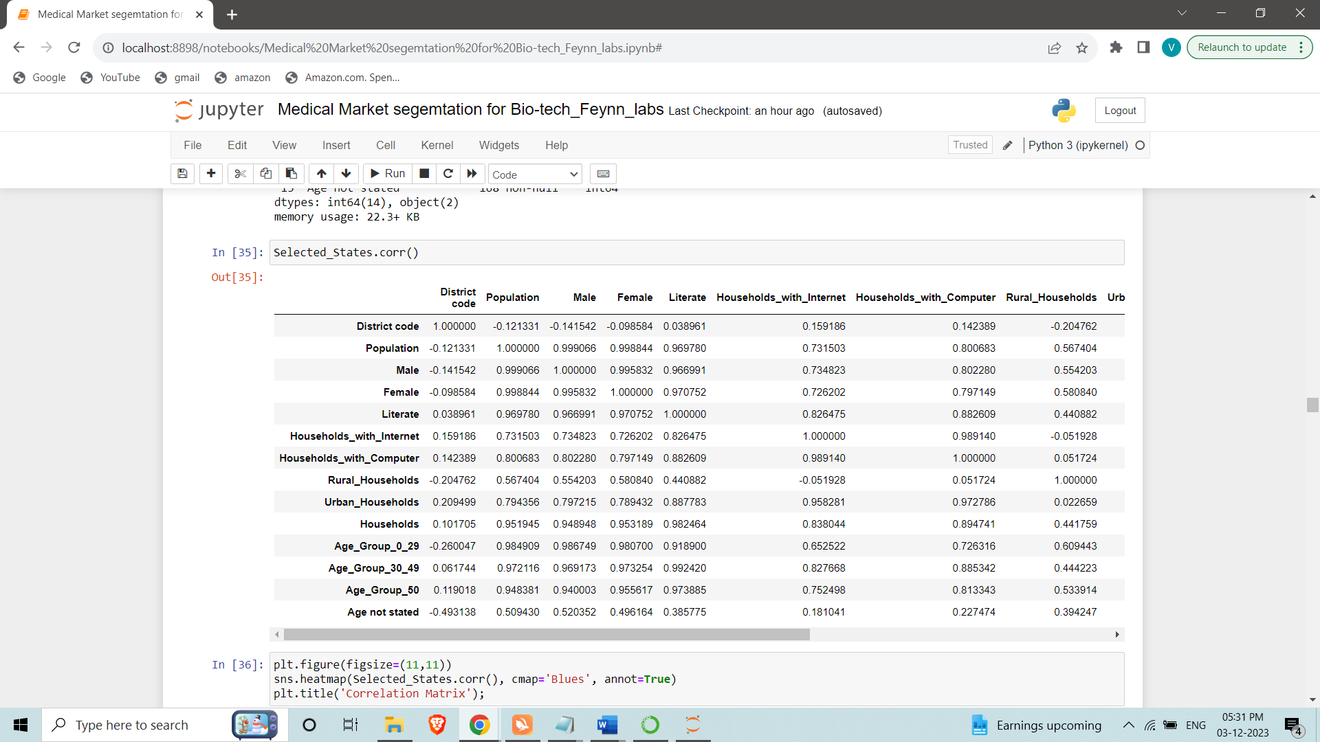

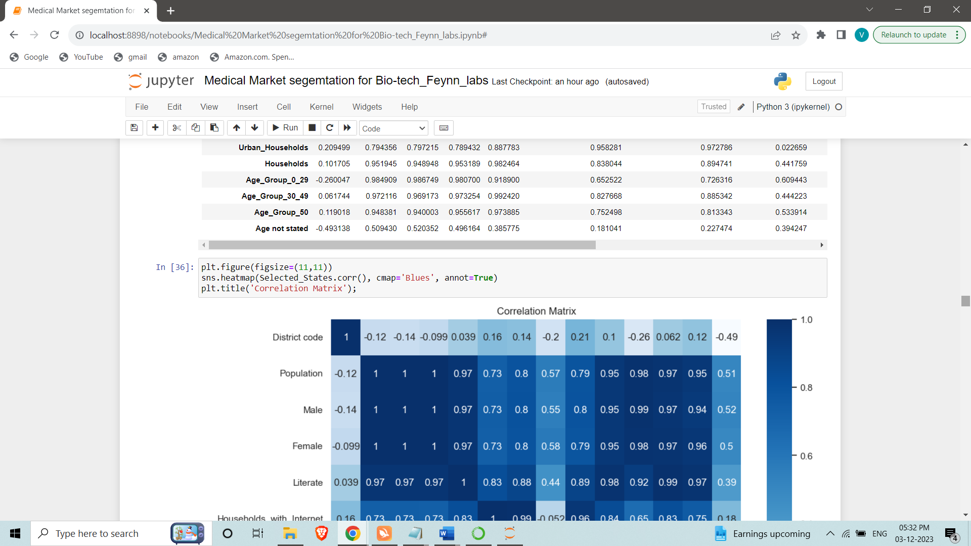

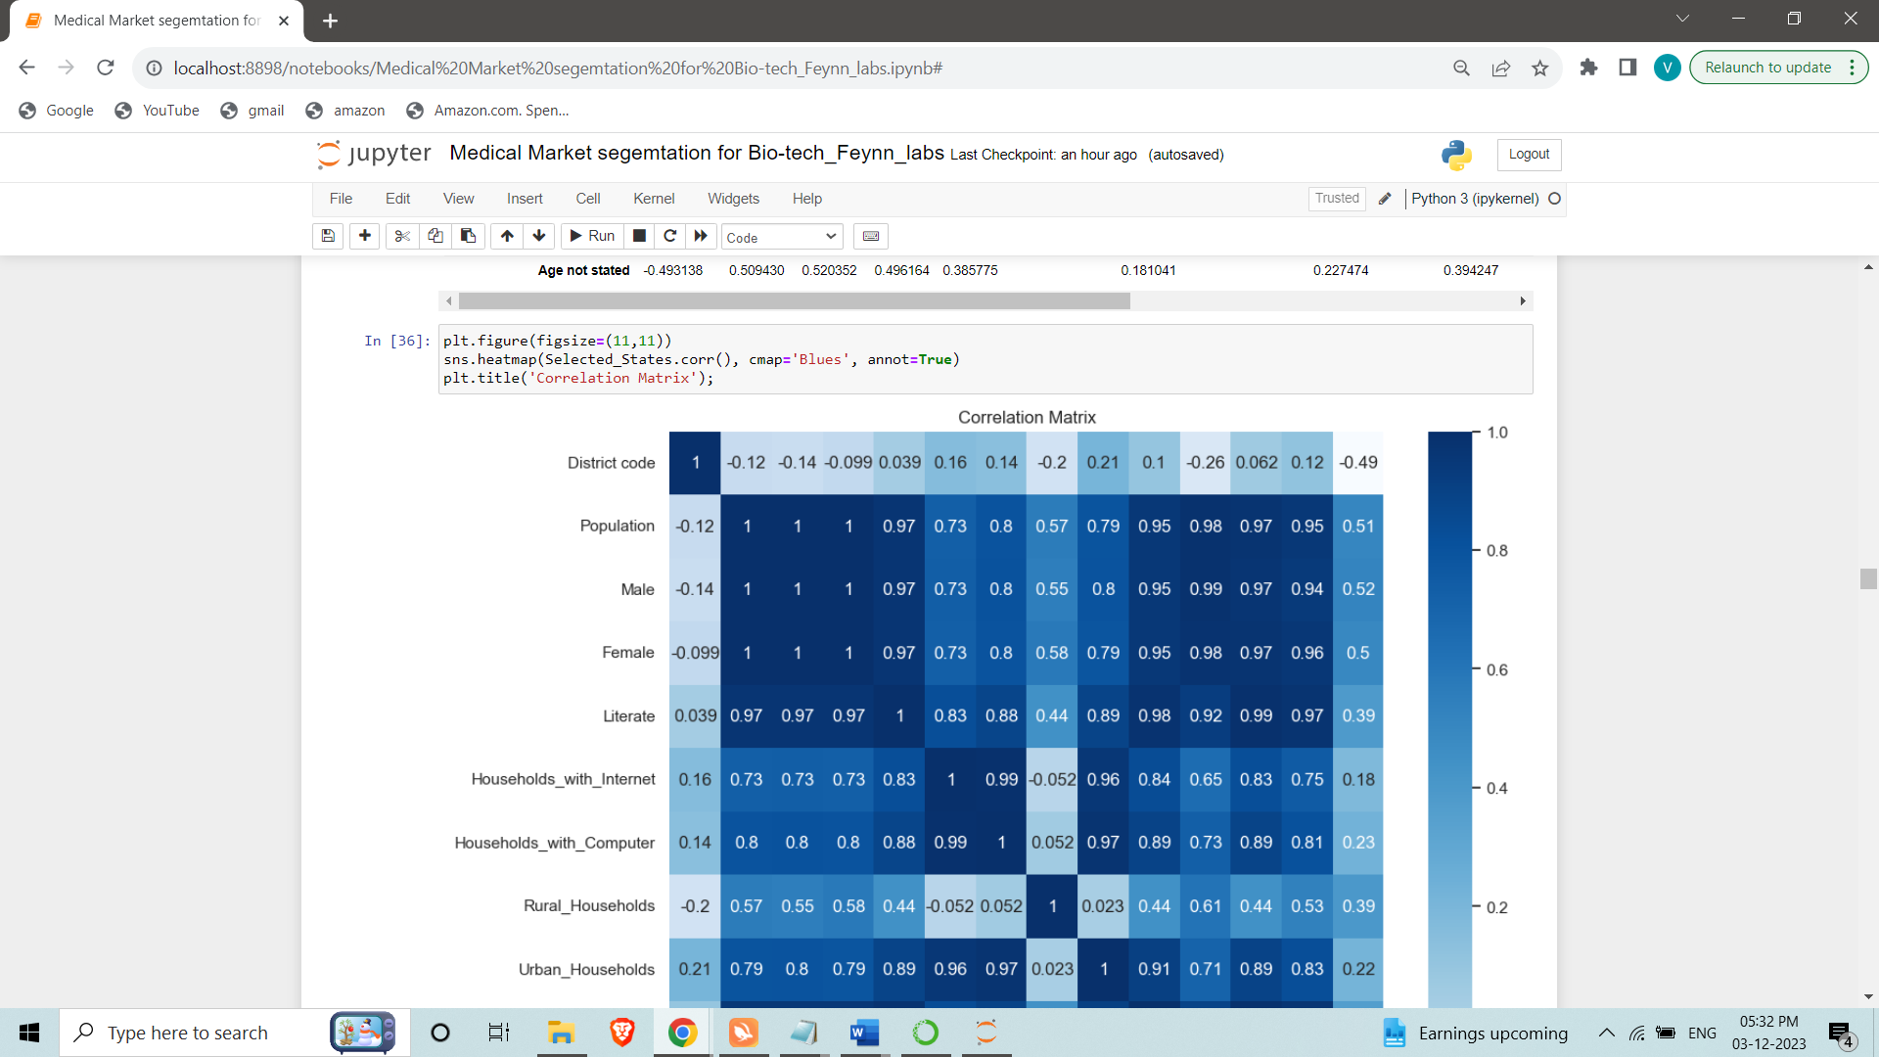

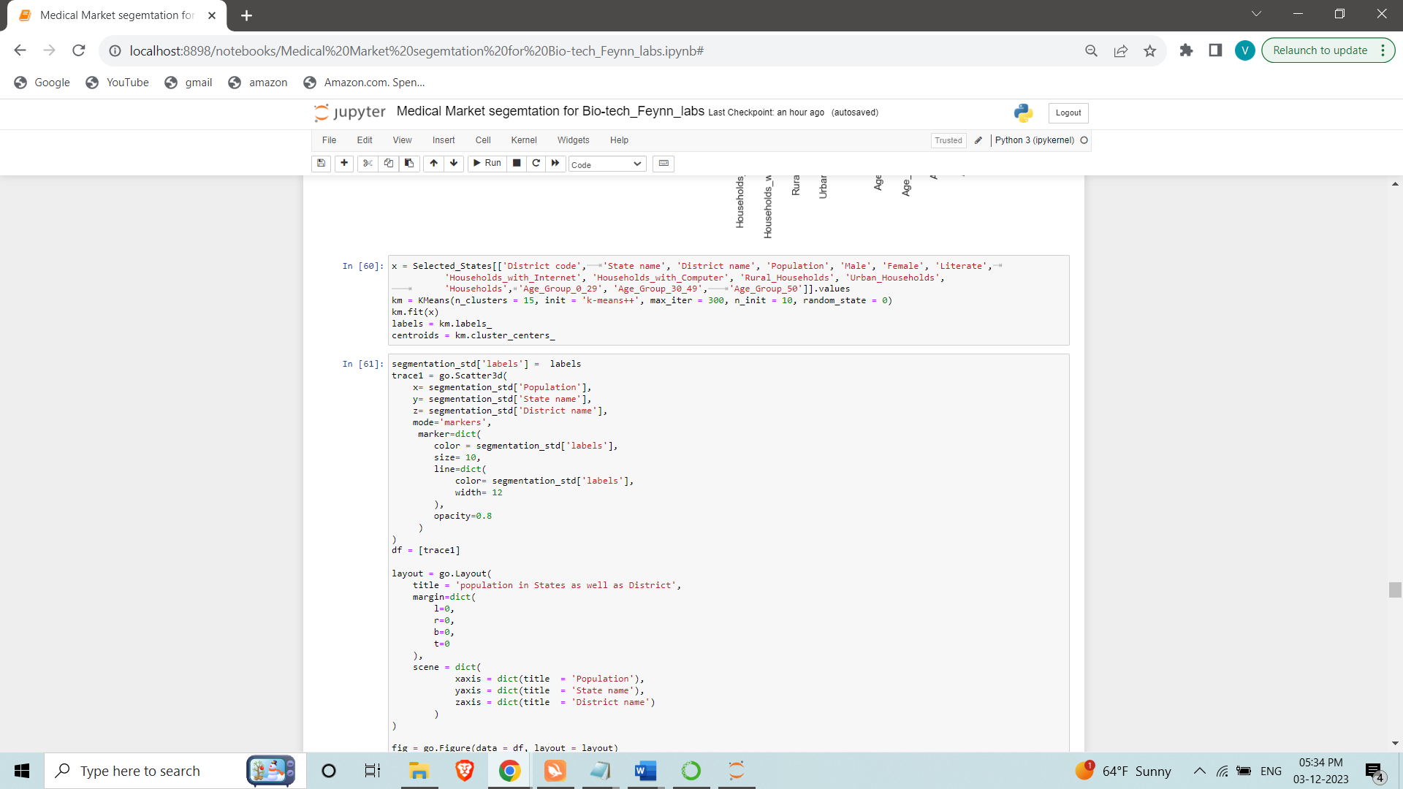

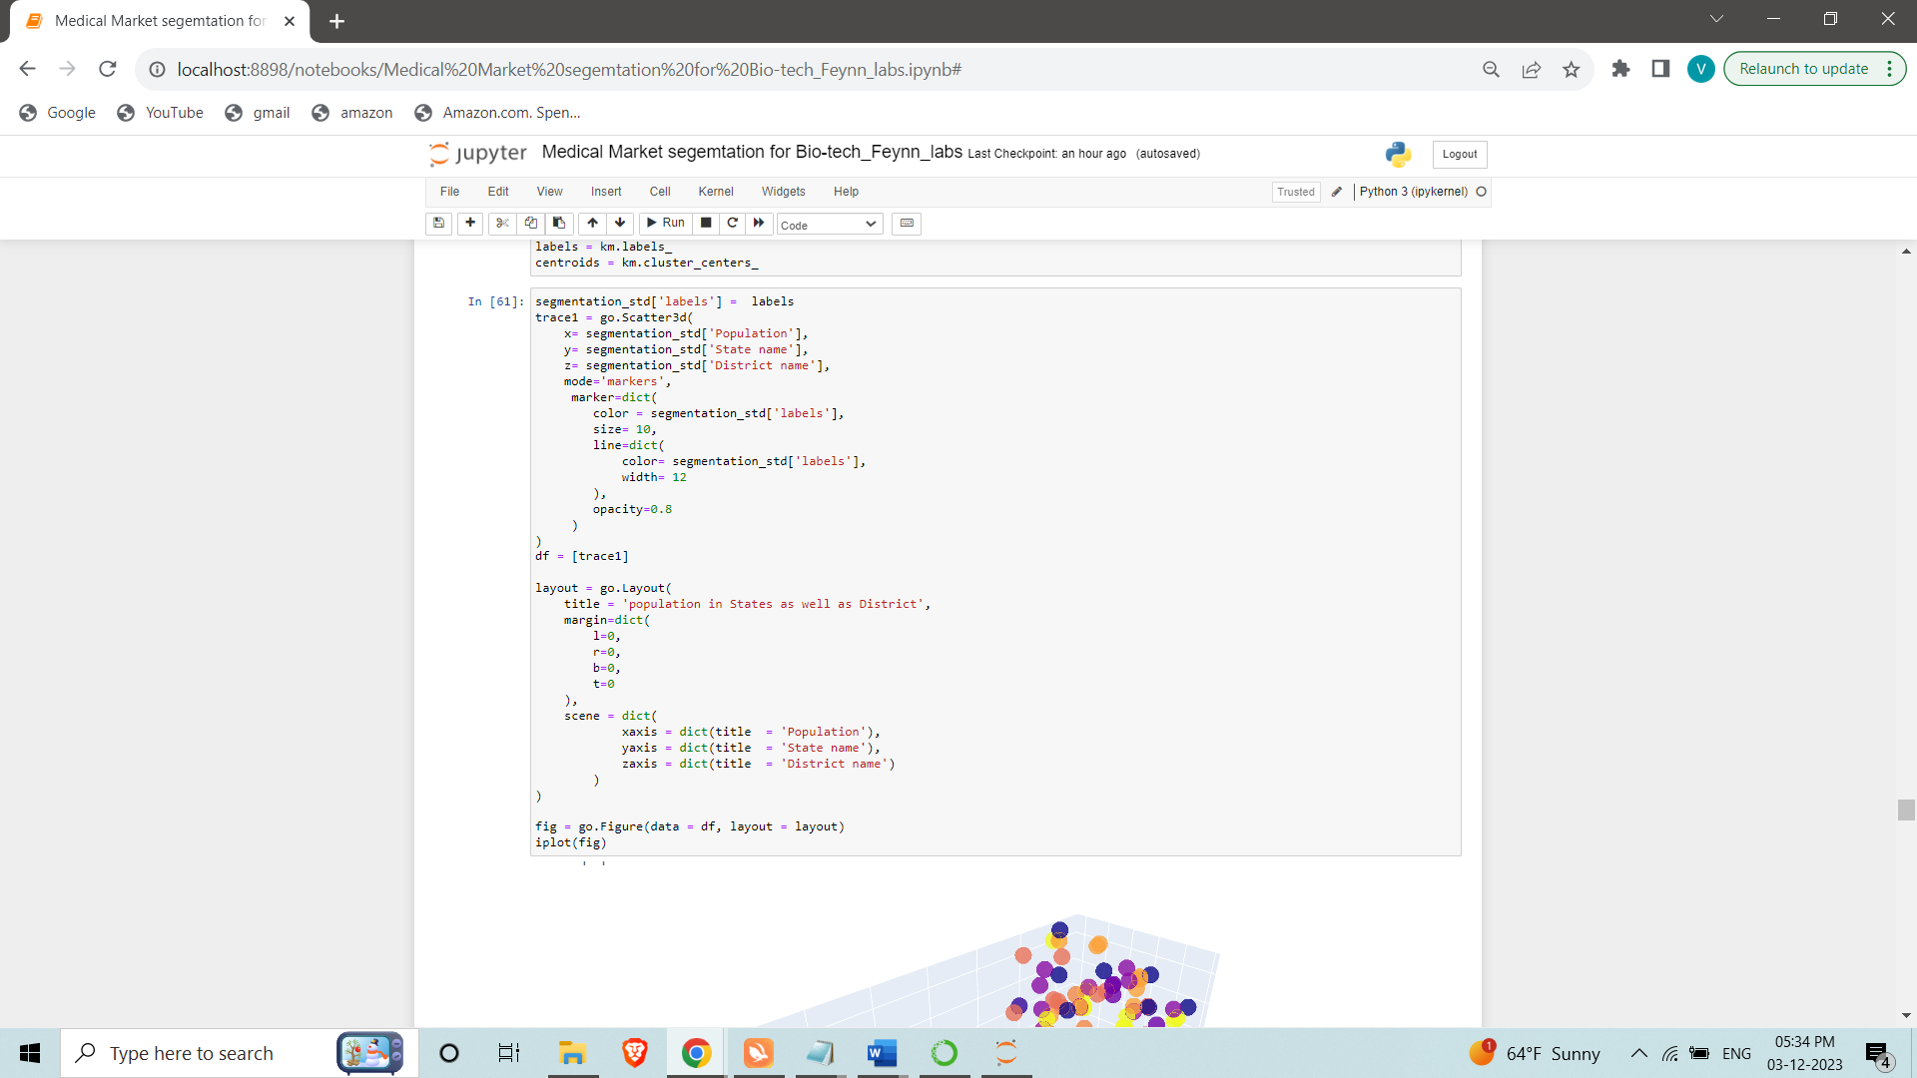

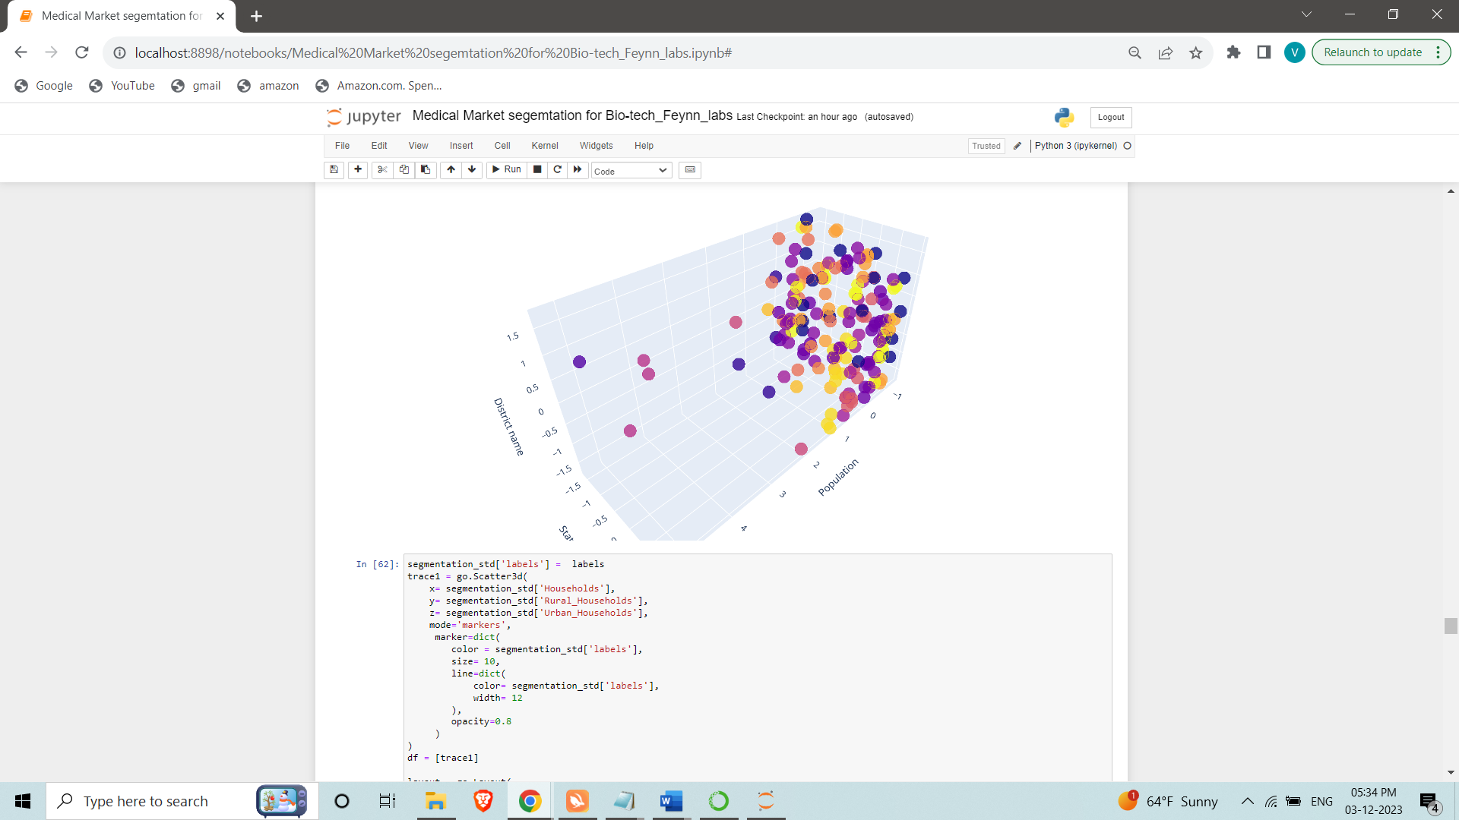

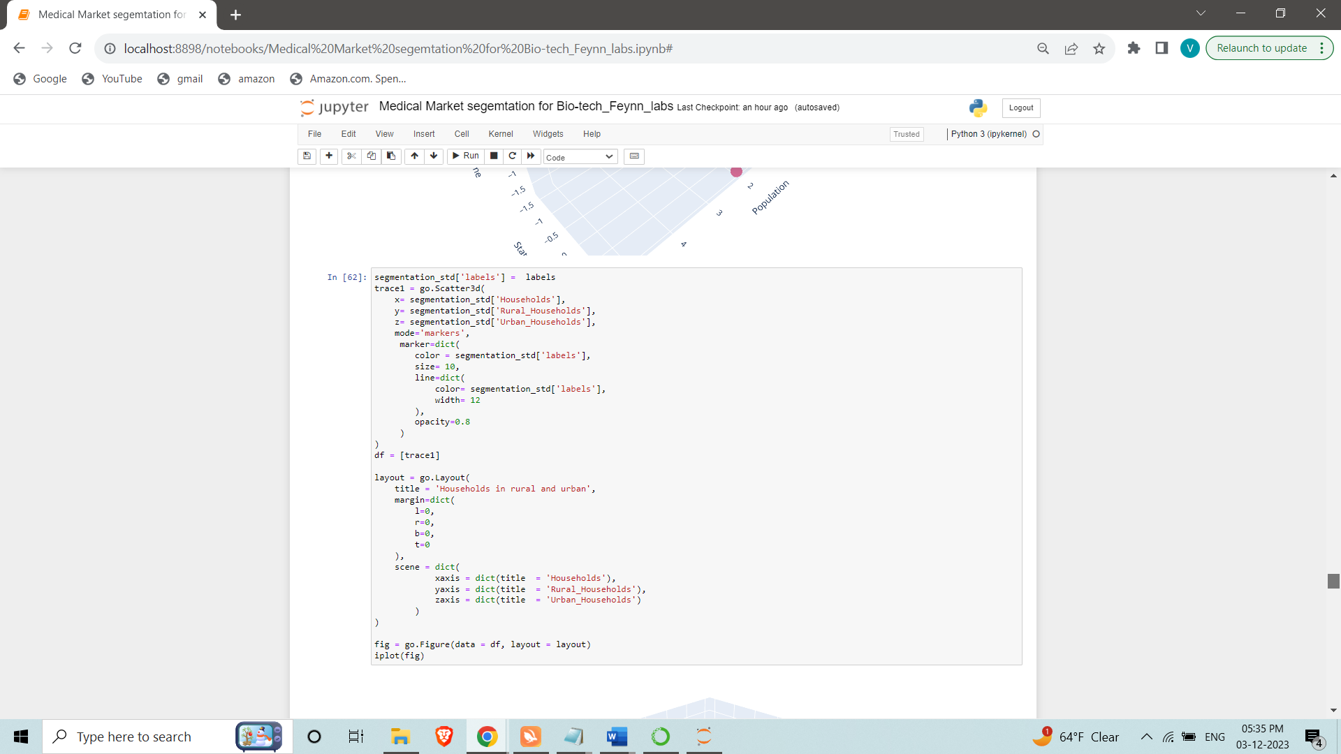

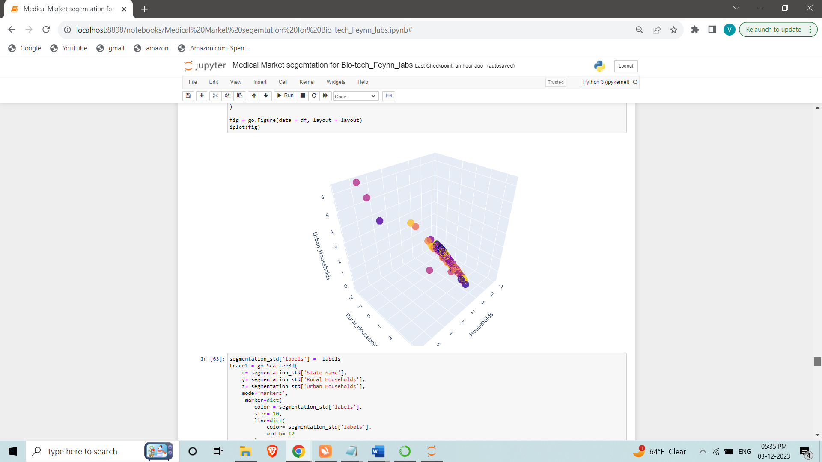

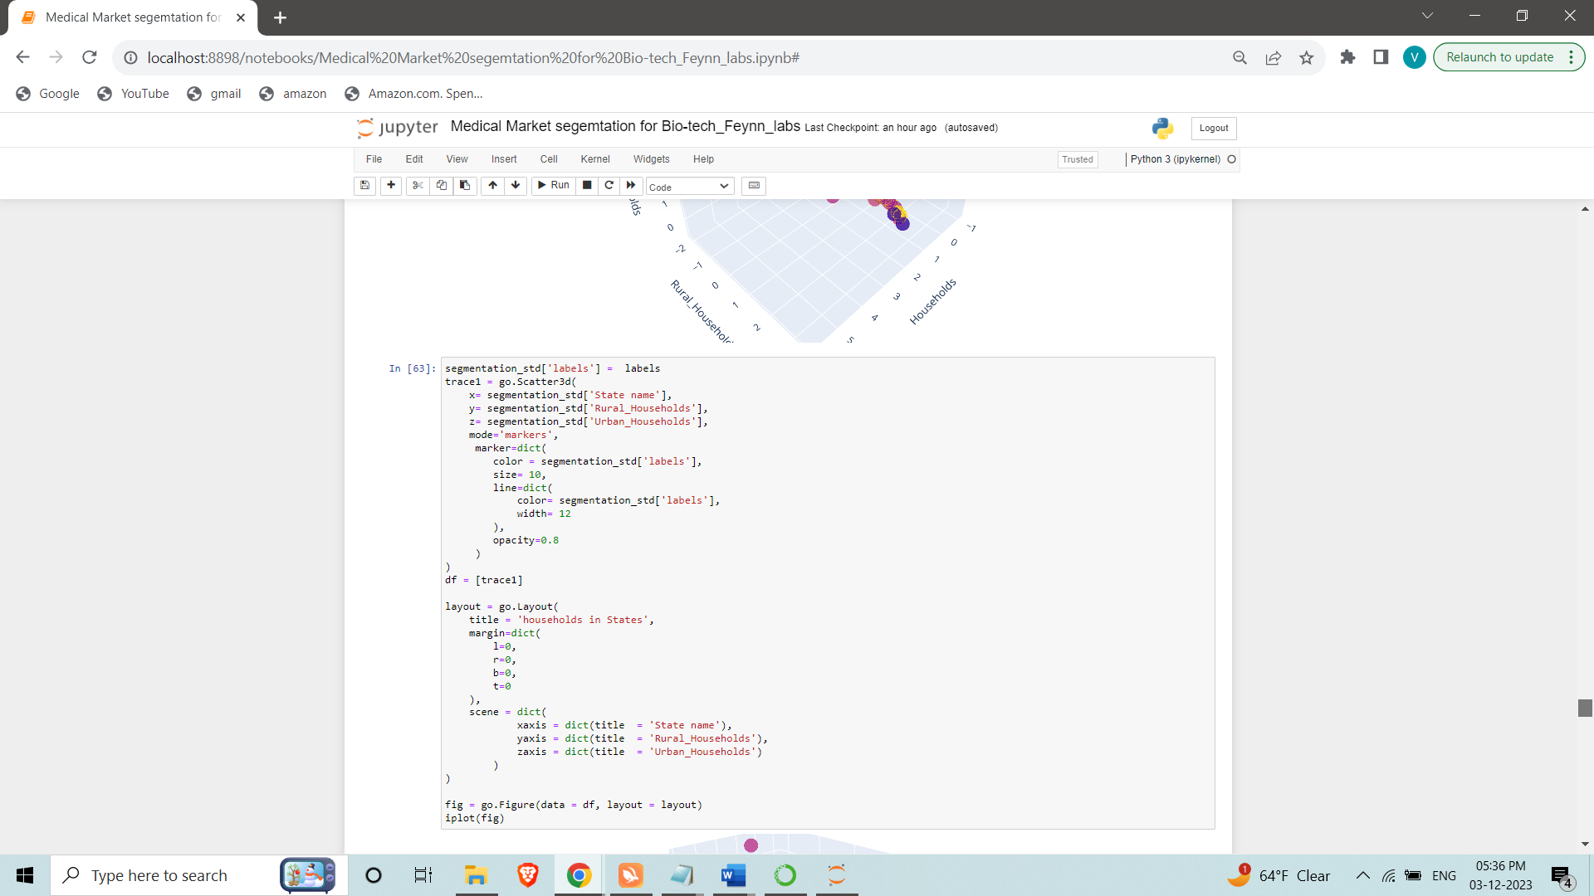

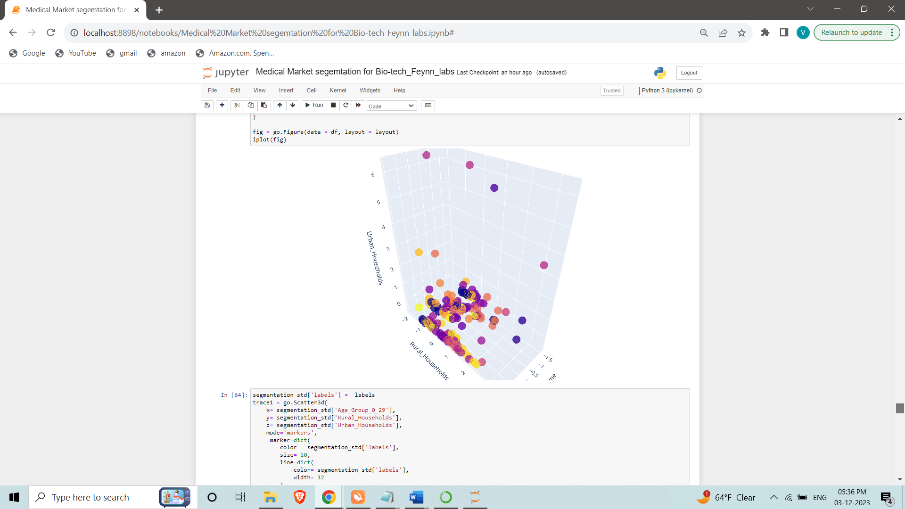

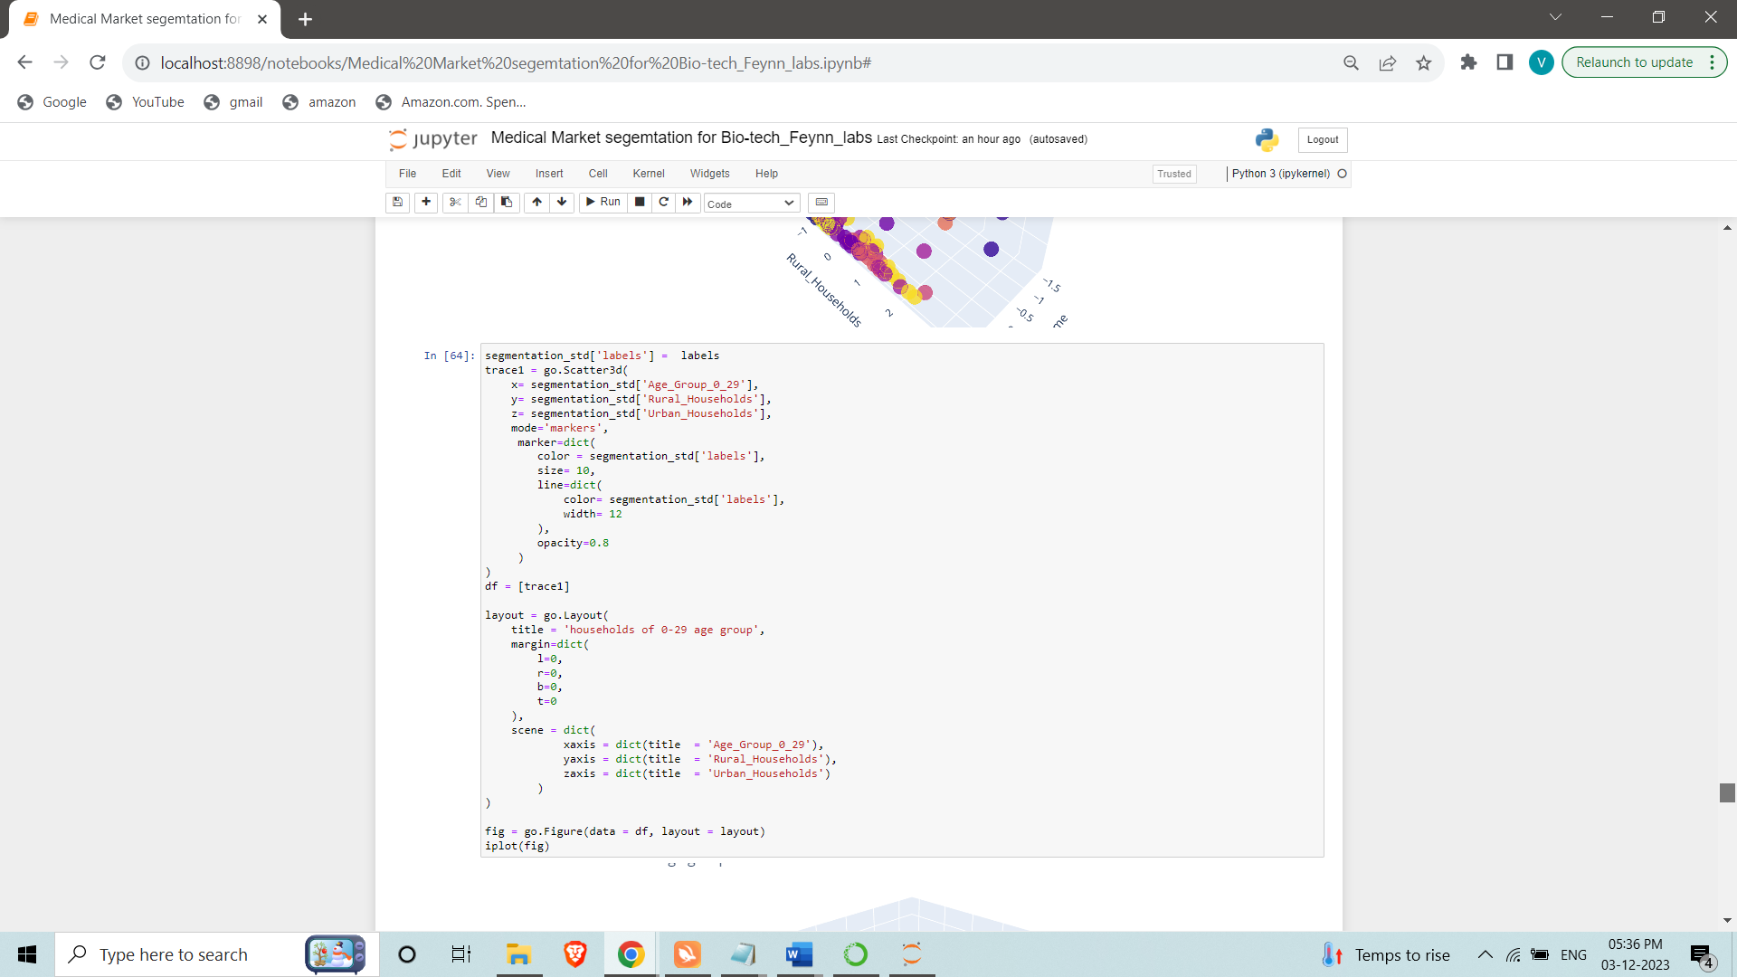

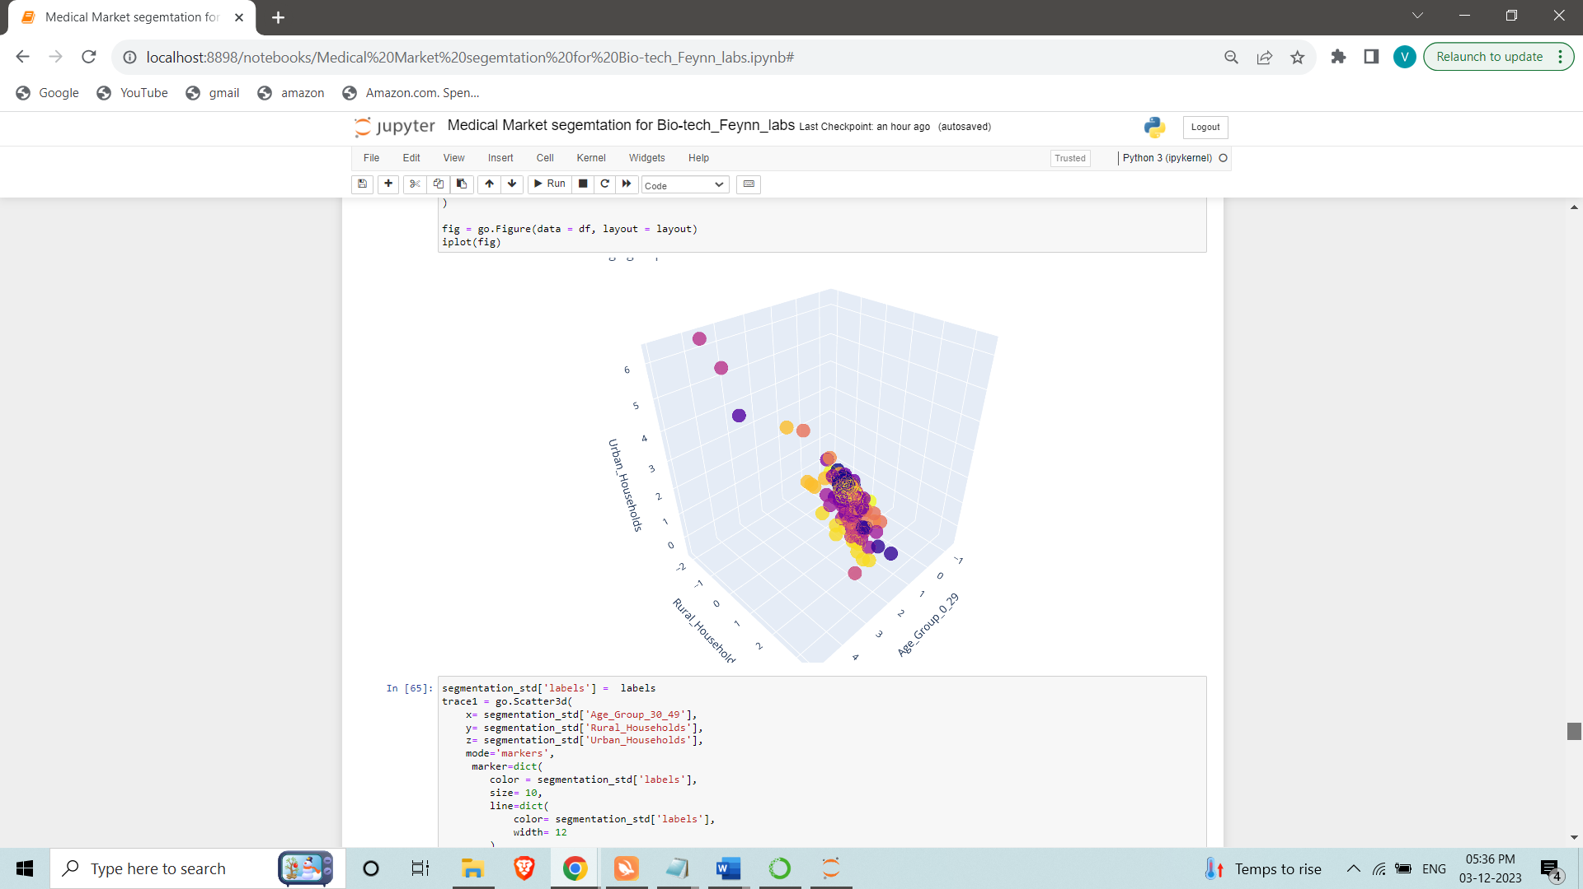

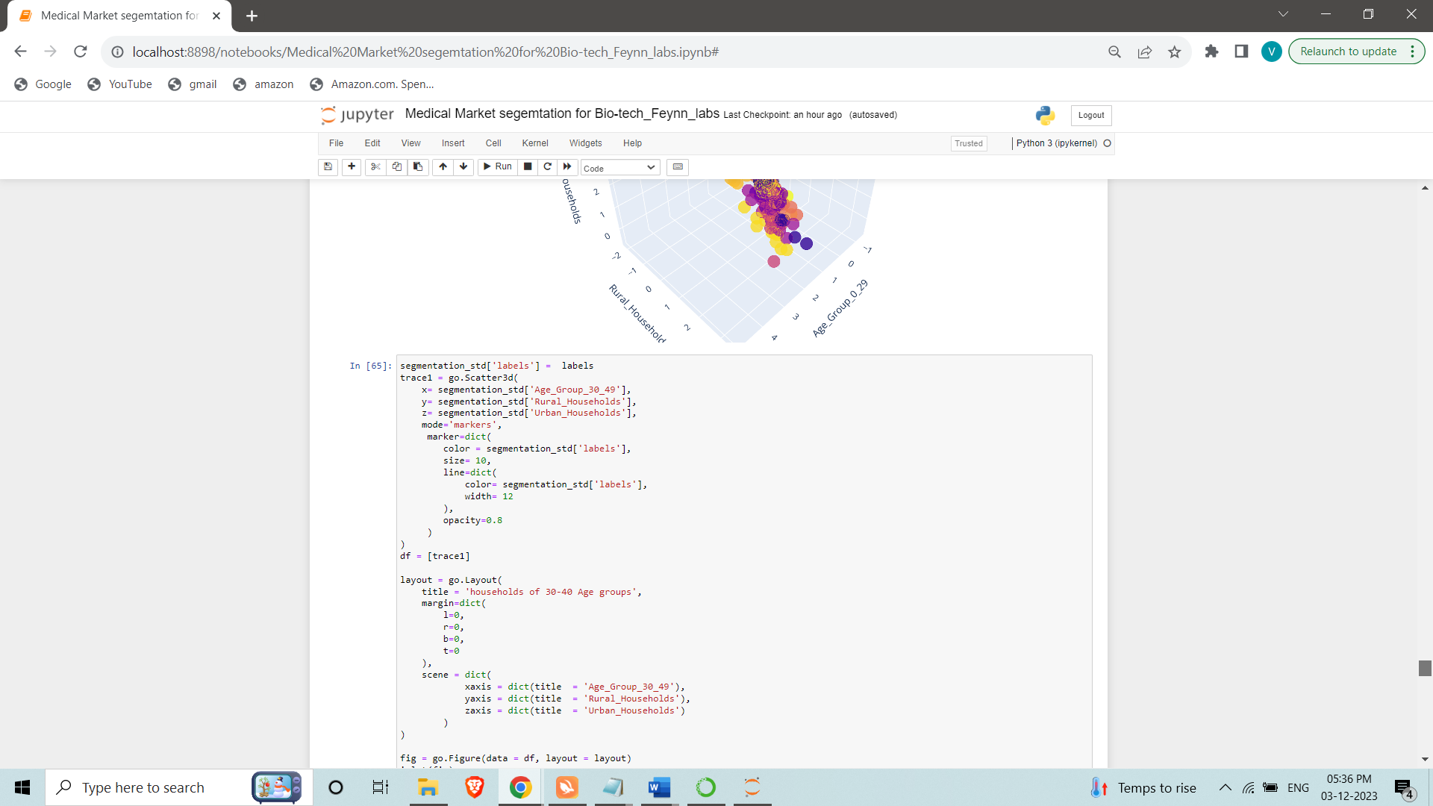

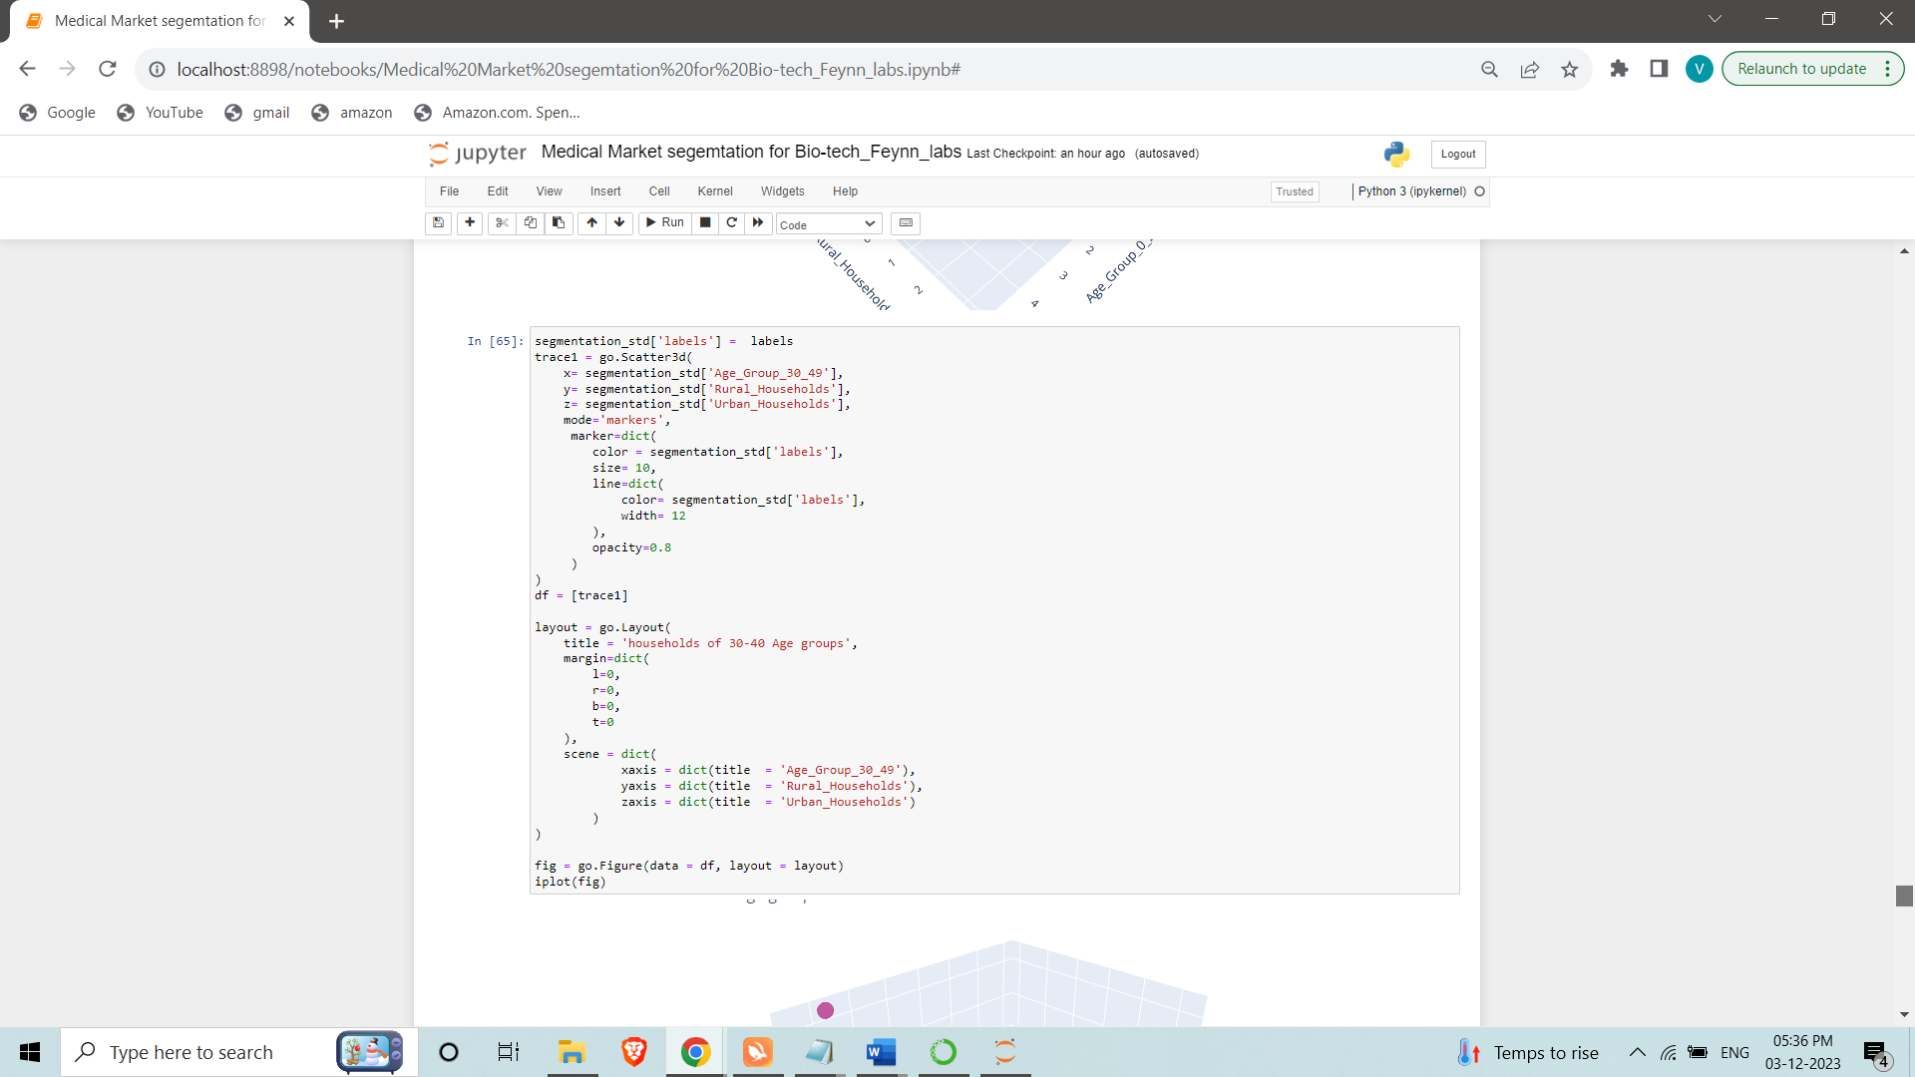



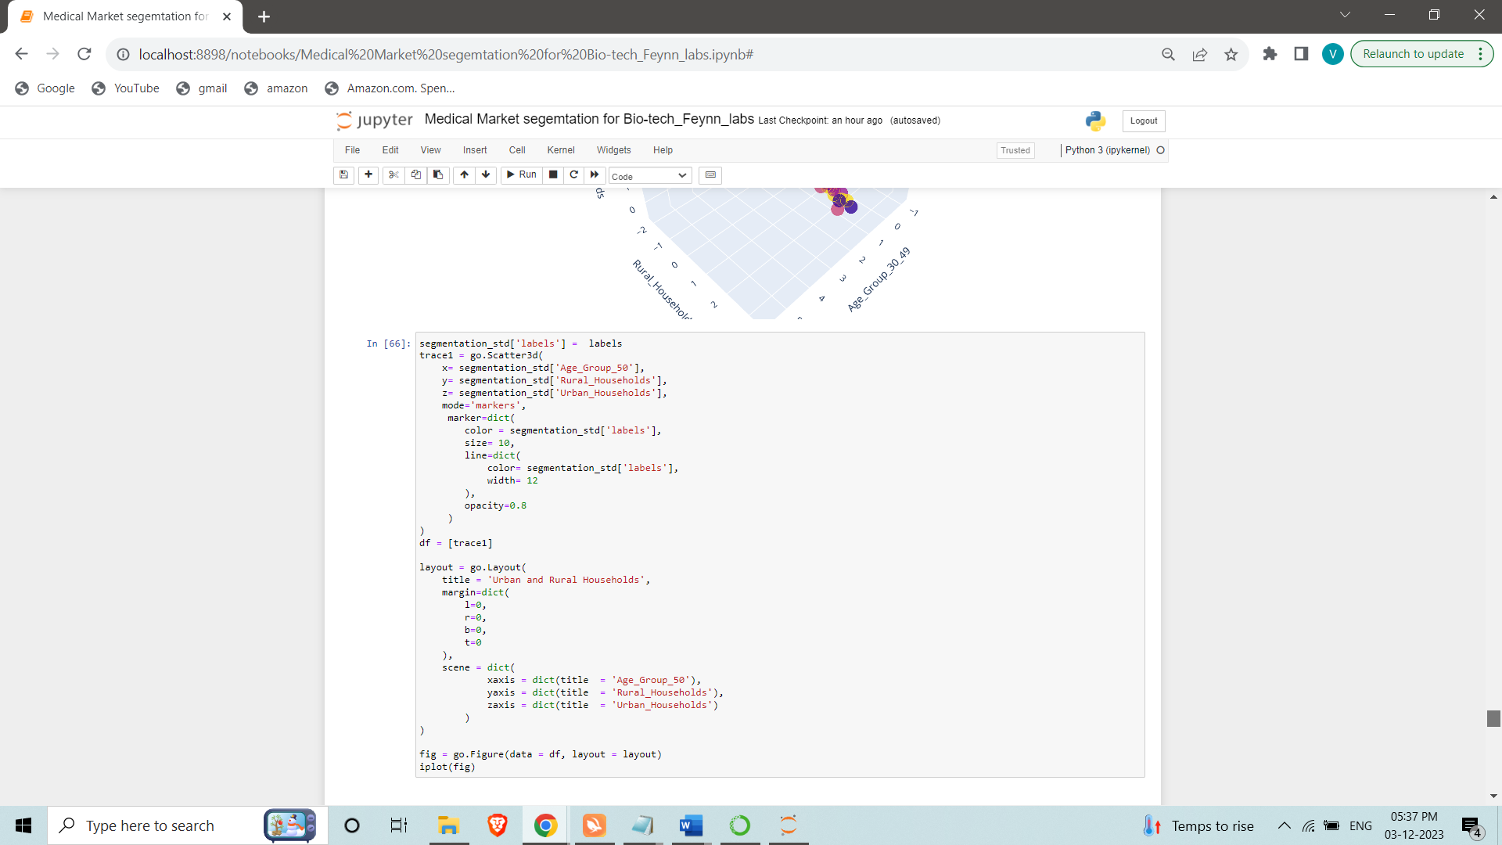

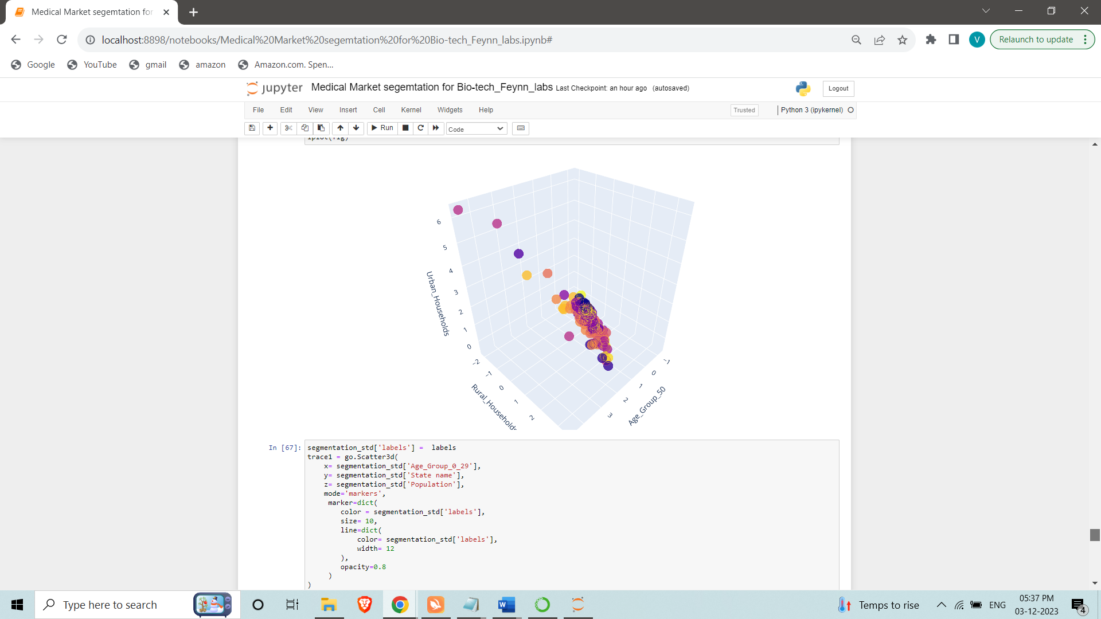

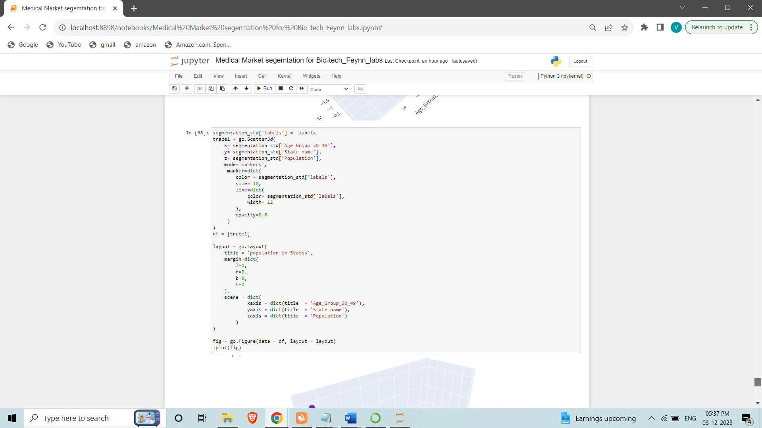

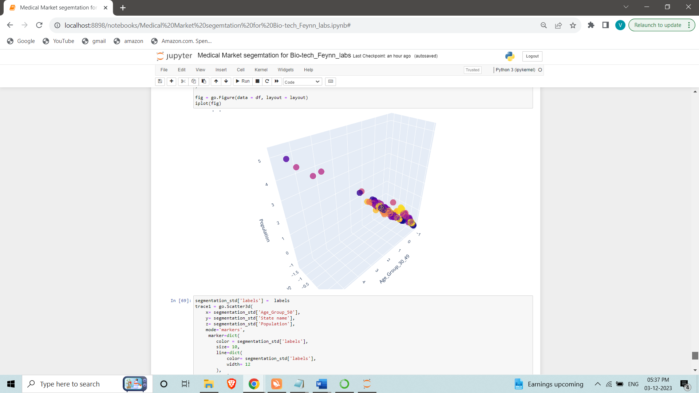

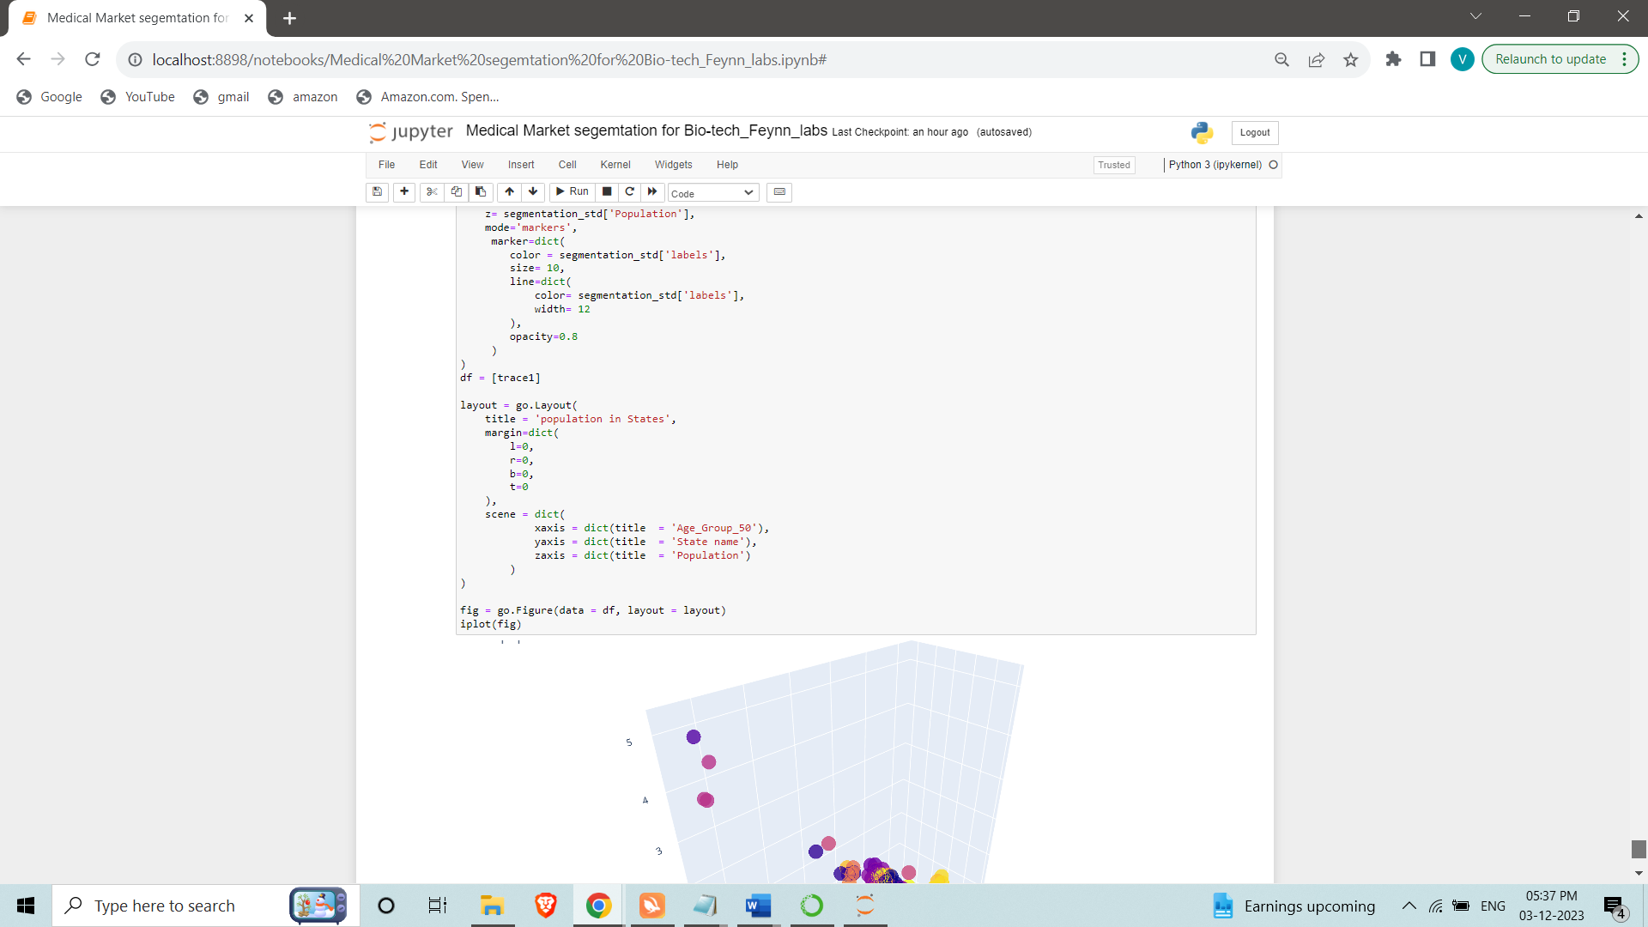

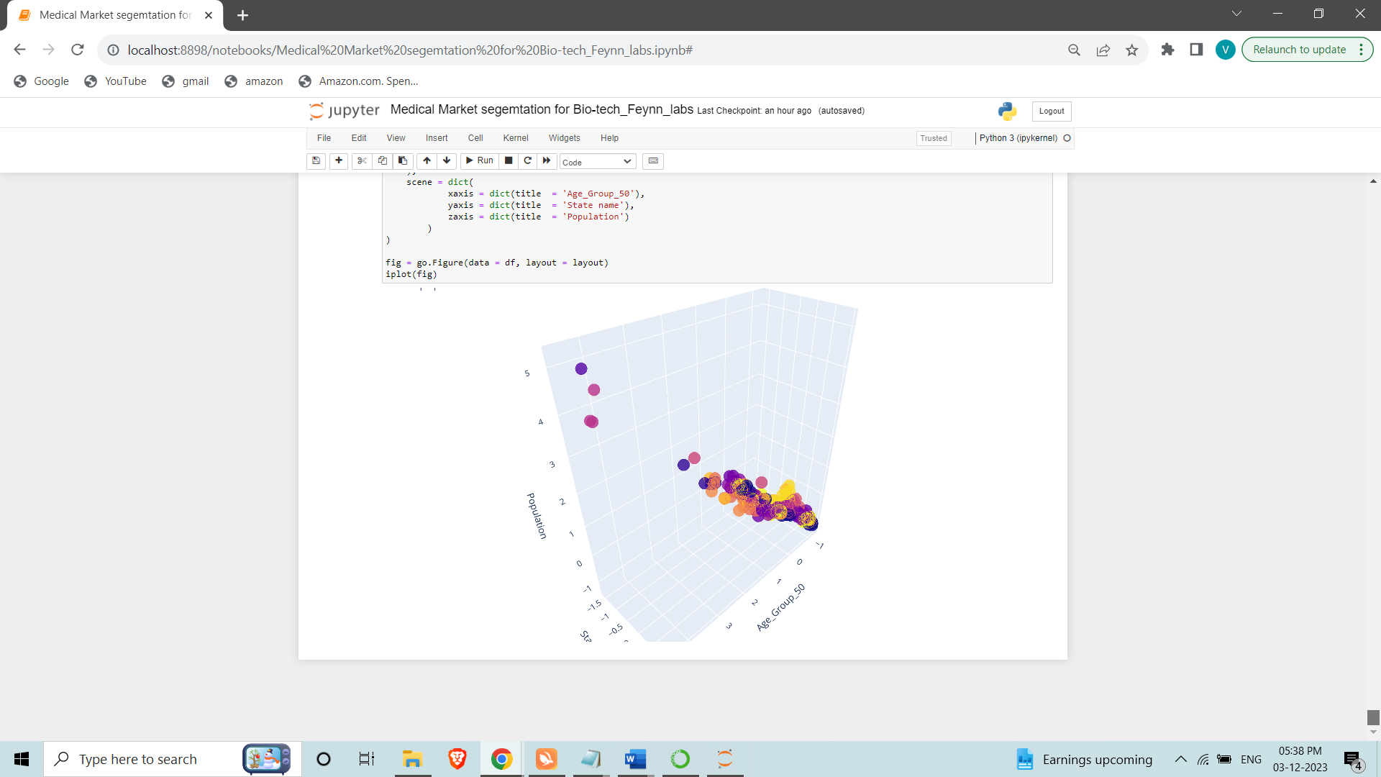

**References**

Office of the Registrar General & Census Commissioner, India. (2011). Census of India 2011 data tables. <https://www.censusindia.gov.in/2011census/population_enumeration.html>

Telecom Regulatory Authority of India. (2022). Telecom subscription reports. Retrieved from <https://www.trai.gov.in/release-publication/reports/telecom-subscription-reports>

NITI Aayog. (2021). Digital health strategy recommendations. Retrieved from <https://www.niti.gov.in/sites/default/files/2022->

08/Digital_Health_Strategy_Recommendations_0.pdf

Ericsson. (2022). Ericsson mobility report. Retrieved from <https://www.ericsson.com/en/reports-and-papers/mobility-report/reports/november-2022>